Git Workflow - Remote repository

Upstream

What is Upstream Tracking?
# Source: AI Source: Provided by: [Data Path: Persons Table -> ID Column: 1, Name_En Column: Motasem Essam] -> From: [Chatgpt (GPT‑5 Mini)] on [2/19/2026]
Upstream tracking means:
Your local branch is linked to a remote branch, so Git knows where to push and pull by default.
When tracking is set, you don’t need to write the remote and branch every time.
Instead of:
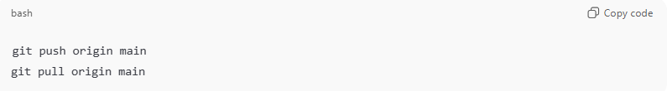
git push origin main
git pull origin main
You can simply use:
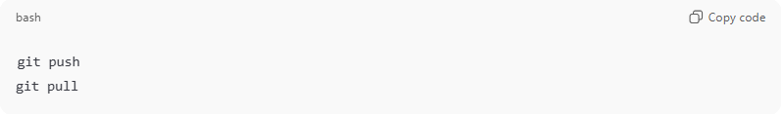
git push
git pull
Git already knows the destination branch.

What does Set Upstream Tracking mean?
# Source: AI Source: Provided by: [Data Path: Persons Table -> ID Column: 1, Name_En Column: Motasem Essam] -> From: [Chatgpt (GPT‑5 Mini)] on [2/19/2026]
It means:
You connect (link) your current local branch to a remote branch for automatic push/pull.
This is usually done the first time you push a new branch.

What is origin
# Source: AI Source: Provided by: [Data Path: Persons Table -> ID Column: 1, Name_En Column: Motasem Essam] -> From: [Chatgpt (GPT‑5 Mini)] on [2/19/2026]
origin = the name of the remote repository (on GitHub).
When you clone a repo, Git automatically names the remote origin.
Example:
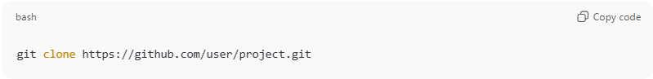
git clone https://github.com/user/project.git

Git internally creates:
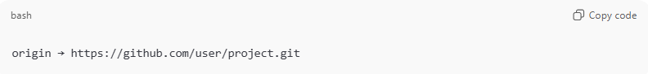
origin → https://github.com/user/project.git
So when you run:
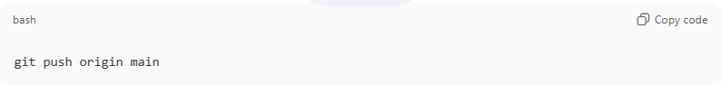
git push origin main
It means:
Push my code to the remote repo called origin.
You can see your remotes with:
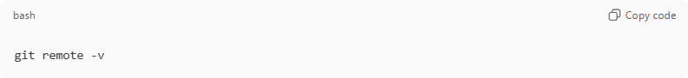
git remote -v

Set Upstream Tracking
# Source: AI Source: Provided by: [Data Path: Persons Table -> ID Column: 1, Name_En Column: Motasem Essam] -> From: [Chatgpt (GPT‑5 Mini)] on [2/19/2026]
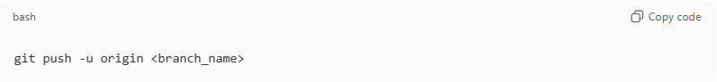
git push -u origin <branch_name>
Example:
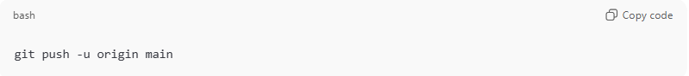
git push -u origin main
What happens here?
- origin → remote repository name
- <branch_name> → remote branch
- -u (or --set-upstream) → tells Git:
“Remember this remote branch for future push & pull.”
After this, you can just use:
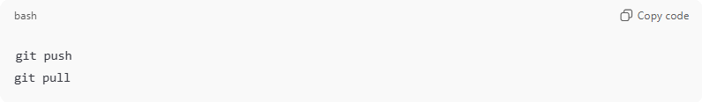
git push
git pull
No need to specify branch again.

How to Check Upstream Tracking
# Source: AI Source: Provided by: [Data Path: Persons Table -> ID Column: 1, Name_En Column: Motasem Essam] -> From: [Chatgpt (GPT‑5 Mini)] on [2/19/2026]
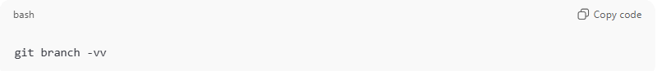
git branch -vv
Example output:
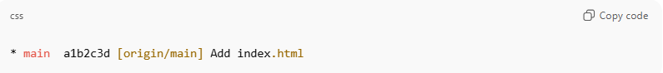
* main a1b2c3d [origin/main] Add index.html
- [origin/main] → your local main is tracking remote origin/main.

If Upstream is NOT Set
# Source: AI Source: Provided by: [Data Path: Persons Table -> ID Column: 1, Name_En Column: Motasem Essam] -> From: [Chatgpt (GPT‑5 Mini)] on [2/19/2026]
When you run:
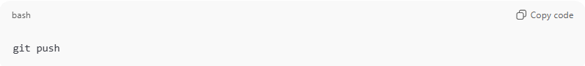
git push
You may see:
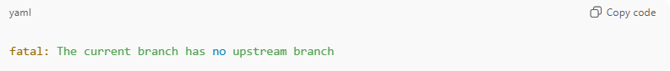
fatal: The current branch has no upstream branch
Fix it by setting upstream:
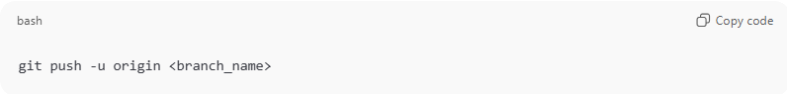
git push -u origin <branch_name>

Change Upstream Branch
# Source: AI Source: Provided by: [Data Path: Persons Table -> ID Column: 1, Name_En Column: Motasem Essam] -> From: [Chatgpt (GPT‑5 Mini)] on [2/19/2026]
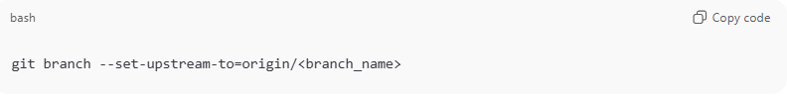
If you want to link your branch to a different remote branch:
git branch --set-upstream-to=origin/<branch_name>

Example
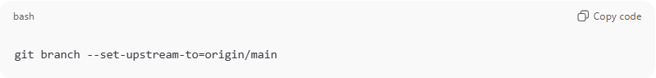
git branch --set-upstream-to=origin/main

Now your local main branch is connected to origin/main, so you can just run:
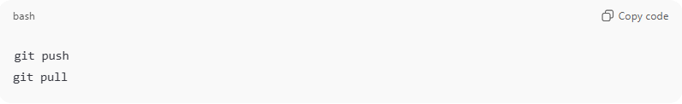

Quick Summary
# Source: AI Source: Provided by: [Data Path: Persons Table -> ID Column: 1, Name_En Column: Motasem Essam] -> From: [Chatgpt (GPT‑5 Mini)] on [2/19/2026]
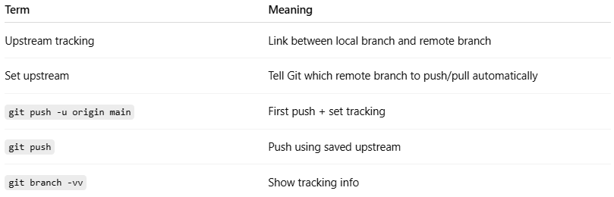
Term | Meaning
Upstream tracking | Link between local branch and remote branch
Set upstream | Tell Git which remote branch to push/pull automatically
git push -u origin main | First push + set tracking
git push | Push using saved upstream
git branch -vv | Show tracking info

Simple Concept
# Source: AI Source: Provided by: [Data Path: Persons Table -> ID Column: 1, Name_En Column: Motasem Essam] -> From: [Chatgpt (GPT‑5 Mini)] on [2/19/2026]
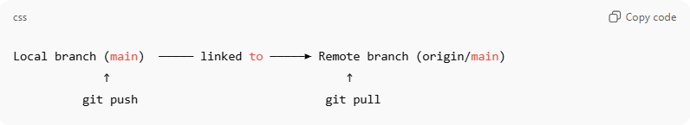
Local branch (main) ───── linked to ─────► Remote branch (origin/main)
↑ ↑
git push git pull

Add Remote Repository Command
# Source: AI Source: Provided by: [Data Path: Persons Table -> ID Column: 1, Name_En Column: Motasem Essam] -> From: [Chatgpt (GPT‑5 Mini)] on [2/19/2026]
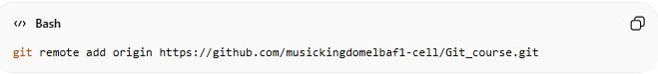
git remote add origin https://github.com/musickingdomelbaf1-cell/Git_course.git

What It Means:
# Source: AI Source: Provided by: [Data Path: Persons Table -> ID Column: 1, Name_En Column: Motasem Essam] -> From: [Chatgpt (GPT‑5 Mini)] on [2/19/2026]
Adds (registers) a remote repository to your local Git project and names it origin.

🔹 What It Does (Simple Explanation)
# Source: AI Source: Provided by: [Data Path: Persons Table -> ID Column: 1, Name_En Column: Motasem Essam] -> From: [Chatgpt (GPT‑5 Mini)] on [2/19/2026]
It connects your local Git repository to a remote repository on GitHub.
It tells Git:
“There is a remote repository at this URL. Call it origin.”

🔍 What Actually Happens Internally
# Source: AI Source: Provided by: [Data Path: Persons Table -> ID Column: 1, Name_En Column: Motasem Essam] -> From: [Chatgpt (GPT‑5 Mini)] on [2/19/2026]
When you run this command:
- Git saves the URL inside your local repository configuration.
- It creates a remote connection named origin.
- It does NOT upload any files.
- It does NOT download anything.
- It only stores the remote address for future use.

🧠 Why origin?
# Source: AI Source: Provided by: [Data Path: Persons Table -> ID Column: 1, Name_En Column: Motasem Essam] -> From: [Chatgpt (GPT‑5 Mini)] on [2/19/2026]
- origin is just a name (alias).
- It is the default name Git uses for the main remote.
- You could name it anything, but origin is standard practice.

📌 What This Enables You To Do
# Source: AI Source: Provided by: [Data Path: Persons Table -> ID Column: 1, Name_En Column: Motasem Essam] -> From: [Chatgpt (GPT‑5 Mini)] on [2/19/2026]
After adding the remote, you can:
Push your code to GitHub:
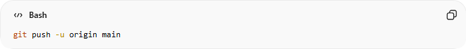
git push -u origin main

Pull changes from GitHub:
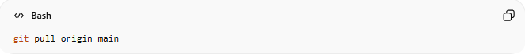
git pull origin main

🔎 How To Verify It Worked
# Source: AI Source: Provided by: [Data Path: Persons Table -> ID Column: 1, Name_En Column: Motasem Essam] -> From: [Chatgpt (GPT‑5 Mini)] on [2/19/2026]
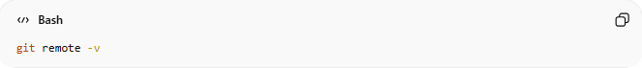
git remote -v
✅ What It Does
Displays the list of remote repositories connected to your local Git project, along with their URLs.
Output:
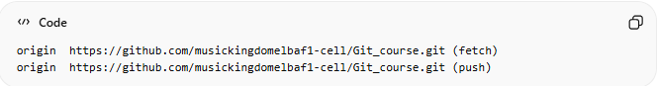
origin https://github.com/musickingdomelbaf1-cell/Git_course.git (fetch)
origin https://github.com/musickingdomelbaf1-cell/Git_course.git (push)

🧠 What This Output Means
- origin → The name (alias) of the remote repository.
- The URL → The address of the remote repository.
- (fetch) → Used when downloading changes (git pull).
- (push) → Used when uploading changes (git push).
Usually, fetch and push URLs are the same, but they can be different.

🚀 Why It’s Useful
- Verify that your local repo is connected to the correct remote.
- Check if the remote URL is correct.
- Confirm that origin exists.
- Debug push/pull problems.

Push Changes to Remote
# Source: AI Source: Provided by: [Data Path: Persons Table -> ID Column: 1, Name_En Column: Motasem Essam] -> From: [Chatgpt (GPT‑5 Mini)] on [2/19/2026]
Case: Using git push (without branch name)
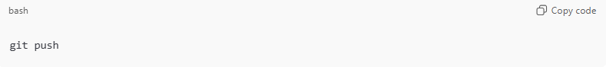
git push

What this does:
- Pushes commits from your current local branch to its tracked (upstream) remote branch.
- Works only if the branch is already linked to a remote branch.
- Usually happens after you previously used:
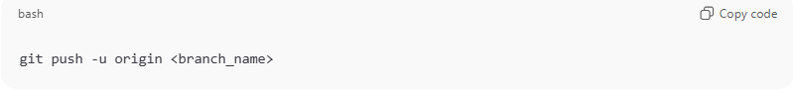
git push -u origin <branch_name>

First Time Pushing a New Branch
# Source: AI Source: Provided by: [Data Path: Persons Table -> ID Column: 1, Name_En Column: Motasem Essam] -> From: [Chatgpt (GPT‑5 Mini)] on [2/19/2026]
If you run:
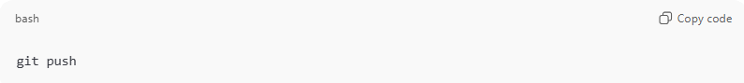
git push
and Git shows an error like:
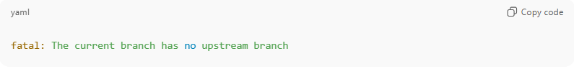
fatal: The current branch has no upstream branch
It means your branch is not linked to any remote branch yet.

Fix (set upstream branch):
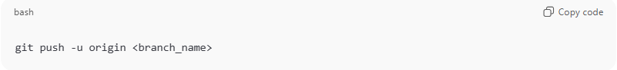
git push -u origin <branch_name>
Example:
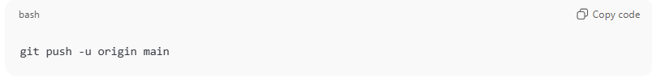
git push -u origin main

After this, you can use simply:
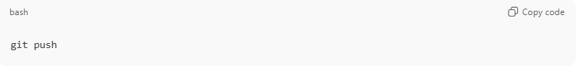
git push
for future pushes.

What git push Uses Automatically
# Source: AI Source: Provided by: [Data Path: Persons Table -> ID Column: 1, Name_En Column: Motasem Essam] -> From: [Chatgpt (GPT‑5 Mini)] on [2/19/2026]
When upstream is set, git push automatically uses:
- Remote: origin (default remote)
- Branch: your current branch
Equivalent to:
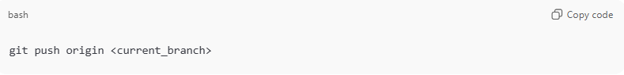
git push origin <current_branch>

Common Situations
# Source: AI Source: Provided by: [Data Path: Persons Table -> ID Column: 1, Name_En Column: Motasem Essam] -> From: [Chatgpt (GPT‑5 Mini)] on [2/19/2026]
1. Normal Push (after upstream set)
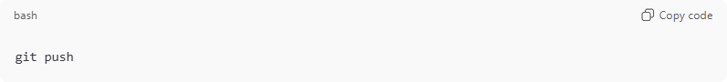
git push
Pushes new commits to remote.

2. Nothing to Push
If no new commits exist:
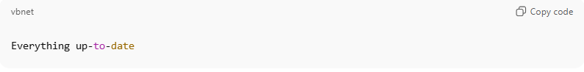
Everything up-to-date

3. After Amend or Rebase
If history changed, normal push may fail:
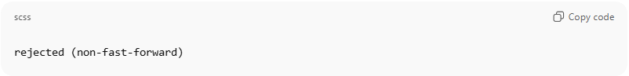
rejected (non-fast-forward)
Use force push carefully:
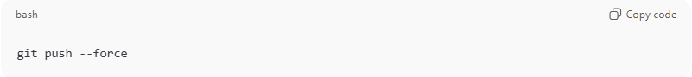
git push --force
⚠ This rewrites remote history.

Quick Summary
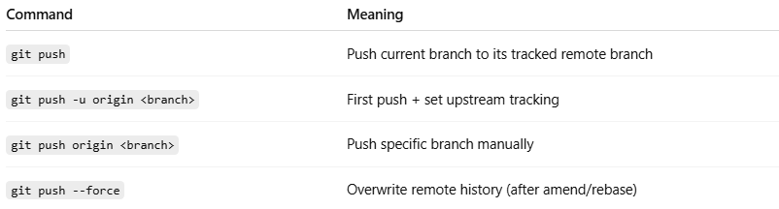
Command | Meaning
git push | Push current branch to its tracked remote branch
git push -u origin <branch> | First push + set upstream tracking
git push origin <branch> | Push specific branch manually
git push --force | Overwrite remote history (after amend/rebase)

Push Tags (Optional)
# Source: AI Source: Provided by: [Data Path: Persons Table -> ID Column: 1, Name_En Column: Motasem Essam] -> From: [Chatgpt (GPT‑5 Mini)] on [2/19/2026]
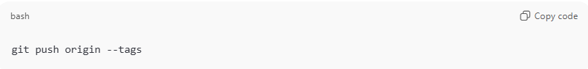
git push origin --tags
- Pushes all tags from local to remote repository.

Force Push (Use Carefully)
# Source: AI Source: Provided by: [Data Path: Persons Table -> ID Column: 1, Name_En Column: Motasem Essam] -> From: [Chatgpt (GPT‑5 Mini)] on [2/19/2026]
If you amended commits or rebased local commits, the history may differ from the remote. To overwrite the remote:
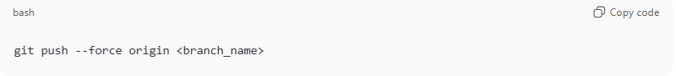
git push --force origin <branch_name>
⚠ Warning:
- This rewrites remote history.
- Only do this if you are sure nobody else is working on the same branch.

Pull Changes From Remote

Pull Changes (Fetch + Merge)
# Source: AI Source: Provided by: [Data Path: Persons Table -> ID Column: 1, Name_En Column: Motasem Essam] -> From: [Chatgpt (GPT‑5 Mini)] on [2/19/2026]
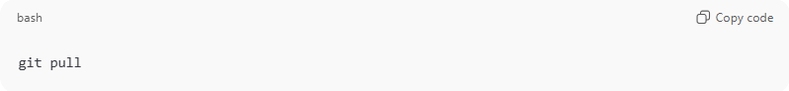
git pull
What it does:
- Downloads changes from the tracked remote branch.
- Automatically merges them into your current local branch.
- Requires upstream tracking to be set.
Equivalent to:
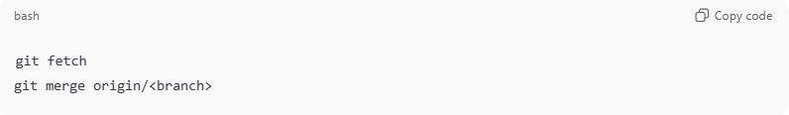
git fetch
git merge origin/<branch>

Pull From Specific Branch
# Source: AI Source: Provided by: [Data Path: Persons Table -> ID Column: 1, Name_En Column: Motasem Essam] -> From: [Chatgpt (GPT‑5 Mini)] on [2/19/2026]
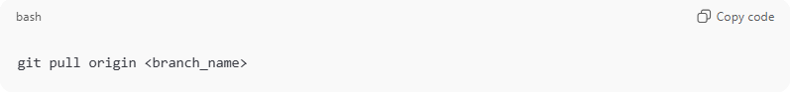
git pull origin <branch_name>
Example:
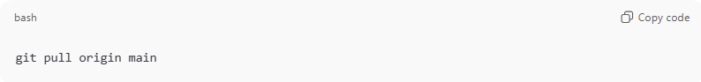
git pull origin main
- Downloads and merges changes from origin/main into your current branch.

2. Fetch Changes (Download Only)
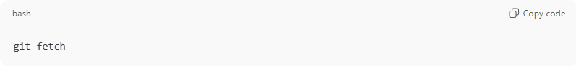
git fetch
What it does:
- Downloads changes from remote.
- Does NOT merge them automatically.
- Lets you review changes before merging.
After fetching, you can merge manually:
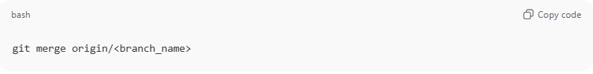
git merge origin/<branch_name>

When to Use Fetch
- To check remote changes safely before merging.
- To avoid automatic merge conflicts.
- To inspect differences:
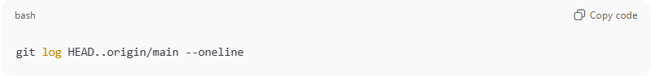
git log HEAD..origin/main --oneline

Clone Repository (First Time Only)
# Source: AI Source: Provided by: [Data Path: Persons Table -> ID Column: 1, Name_En Column: Motasem Essam] -> From: [Chatgpt (GPT‑5 Mini)] on [2/19/2026]
If you don’t have the repo locally yet:
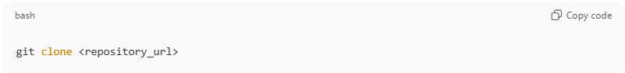
git clone <repository_url>
Example:
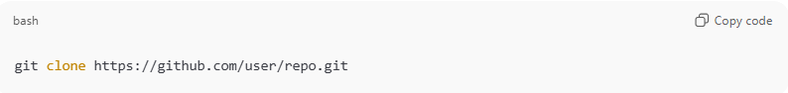
git clone https://github.com/user/repo.git
What it does:
- Downloads the entire repository.
- Creates a local repo.
- Automatically sets upstream tracking.
- Default branch is checked out (usually main).

Pull With Rebase (Optional)
# Source: AI Source: Provided by: [Data Path: Persons Table -> ID Column: 1, Name_En Column: Motasem Essam] -> From: [Chatgpt (GPT‑5 Mini)] on [2/19/2026]
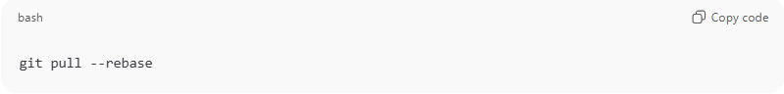
git pull --rebase
- Fetches remote changes.
- Reapplies your local commits on top of remote commits.
- Keeps history linear and clean.

Common Situations
# Source: AI Source: Provided by: [Data Path: Persons Table -> ID Column: 1, Name_En Column: Motasem Essam] -> From: [Chatgpt (GPT‑5 Mini)] on [2/19/2026]
Already Up to Date
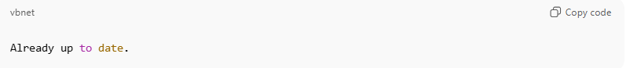
Already up to date.
No new remote changes.

Merge Conflict
# Source: AI Source: Provided by: [Data Path: Persons Table -> ID Column: 1, Name_En Column: Motasem Essam] -> From: [Chatgpt (GPT‑5 Mini)] on [2/19/2026]
If local and remote changed the same lines:
- Git pauses and asks you to resolve conflicts.
- After fixing:
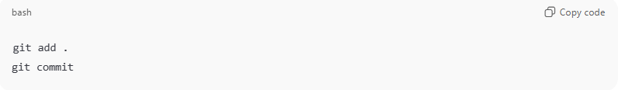
git add .
git commit

Local Behind Remote
Check commits you don’t have yet:
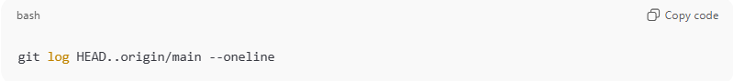
git log HEAD..origin/main --oneline

Quick Summary
# Source: AI Source: Provided by: [Data Path: Persons Table -> ID Column: 1, Name_En Column: Motasem Essam] -> From: [Chatgpt (GPT‑5 Mini)] on [2/19/2026]
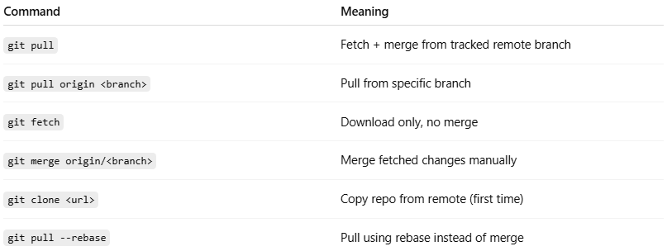
Command | Meaning
git pull | Fetch + merge from tracked remote branch
git pull origin <branch> | Pull from specific branch
git fetch | Download only, no merge
git merge origin/<branch> | Merge fetched changes manually
git clone <url> | Copy repo from remote (first time)
git pull --rebase | Pull using rebase instead of merge

Simple Flow
# Source: AI Source: Provided by: [Data Path: Persons Table -> ID Column: 1, Name_En Column: Motasem Essam] -> From: [Chatgpt (GPT‑5 Mini)] on [2/19/2026]
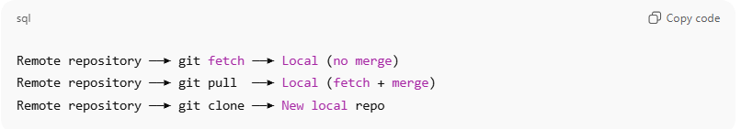
Remote repository ──► git fetch ──► Local (no merge)
Remote repository ──► git pull ──► Local (fetch + merge)
Remote repository ──► git clone ──► New local repo

Merge Conflict
# Source: AI Source: Provided by: [Data Path: Persons Table -> ID Column: 1, Name_En Column: Motasem Essam] -> From: [Chatgpt (GPT‑5 Mini)] on [2/19/2026]
A merge conflict happens in Git when it cannot automatically combine changes from two different sources (branches or commits).
This usually occurs when:
- You and someone else edited the same lines of a file.
- Or, one branch deleted a file while the other branch modified it.

🔍 How Git Shows It
# Source: AI Source: Provided by: [Data Path: Persons Table -> ID Column: 1, Name_En Column: Motasem Essam] -> From: [Chatgpt (GPT‑5 Mini)] on [2/19/2026]
When a merge conflict occurs, Git:
- Stops the merge or pull operation.
- Marks the conflicted files in your working directory.
- Inserts conflict markers in the file like this:
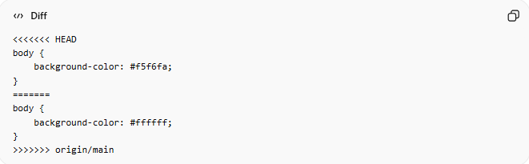
<<<<<<< HEAD
body {
background-color: #f5f6fa;
}
=======
body {
background-color: #ffffff;
}
>>>>>>> origin/main
- <<<<<<< HEAD → your local changes
- ======= → separator
- >>>>>>> origin/main → changes from the remote branch

🛠 How to Resolve It
# Source: AI Source: Provided by: [Data Path: Persons Table -> ID Column: 1, Name_En Column: Motasem Essam] -> From: [Chatgpt (GPT‑5 Mini)] on [2/19/2026]
- Open the conflicted file.
- Decide which code to keep (yours, theirs, or a combination).
- Remove the conflict markers.
- Stage the file with git add <file>.
- Complete the merge with git commit.

🔹 Key Points
# Source: AI Source: Provided by: [Data Path: Persons Table -> ID Column: 1, Name_En Column: Motasem Essam] -> From: [Chatgpt (GPT‑5 Mini)] on [2/19/2026]
- Merge conflicts only happen when Git can’t automatically decide.
- They are normal in collaborative workflows.
- Resolving them requires manual intervention.

💡 Tip: Using tools like VS Code, GitKraken, or GitHub Desktop makes conflicts easier to see and resolve visually.

🔹 When Git Stops for a Conflict
# Source: AI Source: Provided by: [Data Path: Persons Table -> ID Column: 1, Name_En Column: Motasem Essam] -> From: [Chatgpt (GPT‑5 Mini)] on [2/19/2026]
Example scenario:
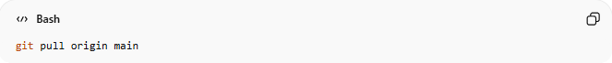
git pull origin main
- Git tries to merge remote changes into your local branch.
- If both you and someone else changed the same lines in the same file, Git can’t automatically merge.
- Git will display a message like:
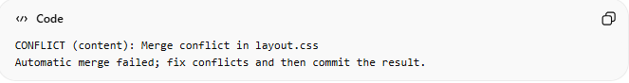
CONFLICT (content): Merge conflict in layout.css
Automatic merge failed; fix conflicts and then commit the result.

🔹 Steps to Resolve Conflicts

1️⃣ Identify Conflicted Files
# Source: AI Source: Provided by: [Data Path: Persons Table -> ID Column: 1, Name_En Column: Motasem Essam] -> From: [Chatgpt (GPT‑5 Mini)] on [2/19/2026]
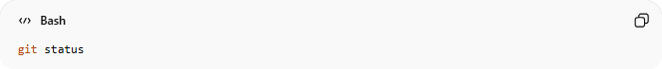
git status
- Look for files marked as “both modified”.
- Example output:
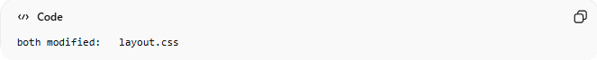
both modified: layout.css

2️⃣ Open the Conflicted File
# Source: AI Source: Provided by: [Data Path: Persons Table -> ID Column: 1, Name_En Column: Motasem Essam] -> From: [Chatgpt (GPT‑5 Mini)] on [2/19/2026]
In the file, you will see conflict markers like:
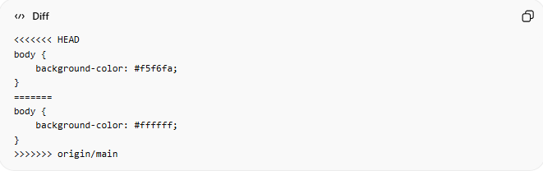
<<<<<<< HEAD
body {
background-color: #f5f6fa;
}
=======
body {
background-color: #ffffff;
}
>>>>>>> origin/main
- <<<<<<< HEAD → Your local changes
- ======= → Separator
- >>>>>>> origin/main → Changes from the remote branch

3️⃣ Edit the File to Resolve the Conflict
# Source: AI Source: Provided by: [Data Path: Persons Table -> ID Column: 1, Name_En Column: Motasem Essam] -> From: [Chatgpt (GPT‑5 Mini)] on [2/19/2026]
- Decide which code to keep:
  - Keep your changes
  - Keep remote changes
  - Combine them
- Remove the conflict markers (<<<<<<<, =======, >>>>>>>).
Example resolved version:
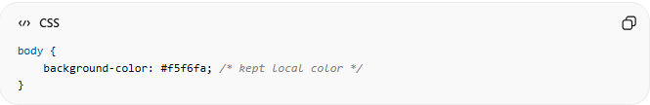
body {
background-color: #f5f6fa; /* kept local color */
}

4️⃣ Mark the Conflict as Resolved
# Source: AI Source: Provided by: [Data Path: Persons Table -> ID Column: 1, Name_En Column: Motasem Essam] -> From: [Chatgpt (GPT‑5 Mini)] on [2/19/2026]
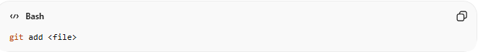
git add <file>
- Example:
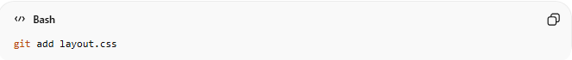
git add layout.css
- This tells Git the conflict has been resolved.

5️⃣ Complete the Merge
# Source: AI Source: Provided by: [Data Path: Persons Table -> ID Column: 1, Name_En Column: Motasem Essam] -> From: [Chatgpt (GPT‑5 Mini)] on [2/19/2026]
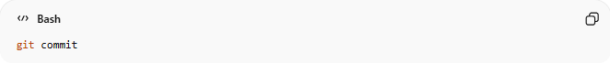
git commit
- Git will automatically create a merge commit with a default message like:
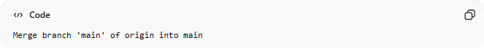
Merge branch 'main' of origin into main

💡 Tip:
# Source: AI Source: Provided by: [Data Path: Persons Table -> ID Column: 1, Name_En Column: Motasem Essam] -> From: [Chatgpt (GPT‑5 Mini)] on [2/19/2026]
If you want a visual tool to resolve conflicts, you can use:
- VS Code → Source Control tab (conflicts highlighted)
- GitKraken
- GitHub Desktop

✅ Summary Workflow
# Source: AI Source: Provided by: [Data Path: Persons Table -> ID Column: 1, Name_En Column: Motasem Essam] -> From: [Chatgpt (GPT‑5 Mini)] on [2/19/2026]
- git status → see which files have conflicts
- Open and manually fix conflicts
- git add <file> → mark resolved
- git commit → finalize merge

From Local repository to Remote repository
# Source: AI Source: Provided by: [Data Path: Persons Table -> ID Column: 1, Name_En Column: Motasem Essam] -> From: [Chatgpt (GPT‑5 Mini)] on [2/19/2026]
Perfect! Let’s cover how to move changes from your Local Repository → Remote Repository in Git. This is essentially pushing commits to a remote like GitHub.
Once your changes are safely in your local repository (committed), you can send them to a remote repository so others can access them or so they are backed up online.

Add Remote Repository
# Source: AI Source: Provided by: [Data Path: Persons Table -> ID Column: 1, Name_En Column: Motasem Essam] -> From: [Chatgpt (GPT‑5 Mini)] on [2/19/2026]

git remote add origin https://github.com/musickingdomelbaf1-cell/Git_course.git

Verify Remote URL
# Source: AI Source: Provided by: [Data Path: Persons Table -> ID Column: 1, Name_En Column: Motasem Essam] -> From: [Chatgpt (GPT‑5 Mini)] on [2/19/2026]

git remote -v

Set Upstream Branch

🔹 1. Set Upstream While Pushing (Push + Track)
# Source: AI Source: Provided by: [Data Path: Persons Table -> ID Column: 1, Name_En Column: Motasem Essam] -> From: [Chatgpt (GPT‑5 Mini)] on [2/19/2026]
- Syntax:
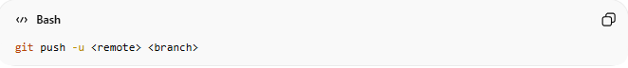
git push -u <remote> <branch>
- Example:
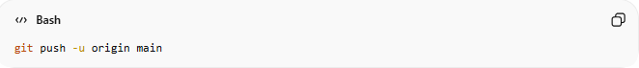
git push -u origin main
- Description:
Pushes your local branch to the remote repository and sets it as the upstream (tracking) branch in one step,
What It Does:
  - Pushes your local branch to the remote.
  - Creates the branch on the remote (if it doesn’t exist).
  - Sets the upstream (tracking) branch automatically.
- When to Use:
Use this the first time you push a new local branch to the remote repository.
After this, you can simply use:
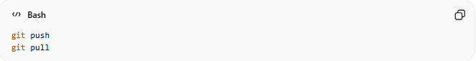
git push
git pull
without specifying the remote or branch again.
✅ Most common and recommended method for first-time push.

🔹 2. Set Upstream Manually (Without Pushing)
# Source: AI Source: Provided by: [Data Path: Persons Table -> ID Column: 1, Name_En Column: Motasem Essam] -> From: [Chatgpt (GPT‑5 Mini)] on [2/19/2026]
- Syntax:
git branch --set-upstream-to=<remote>/<branch> <local-branch>
- Example:
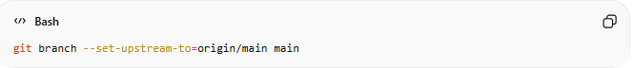
git branch --set-upstream-to=origin/main main
- Description:
Links your local branch to an existing remote branch without pushing anything.
This is useful when the remote branch already exists and you just need to connect them.
- When to Use:
  - The remote branch already exists.
  - You already pushed before.
  - Or you cloned a project and need to link a local branch to an existing remote branch.
- What It Does:

✅ Quick Difference
# Source: AI Source: Provided by: [Data Path: Persons Table -> ID Column: 1, Name_En Column: Motasem Essam] -> From: [Chatgpt (GPT‑5 Mini)] on [2/19/2026]
- git push -u origin main → Push + Set upstream
- git branch --set-upstream-to=origin/main main → Only set upstream (no push)

Upload Local Changes to Remote

Push files and folders

🔹 1. Normal Push (git push)
# Source: AI Source: Provided by: [Data Path: Persons Table -> ID Column: 1, Name_En Column: Motasem Essam] -> From: [Chatgpt (GPT‑5 Mini)] on [2/19/2026]
- Syntax:
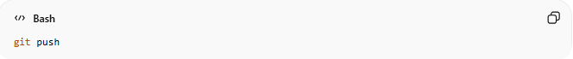
git push
- Description:
Pushes commits from your current local branch to the remote branch it is tracking (upstream).
Use this when you just want to upload your changes without specifying the branch or remote.
- Example:
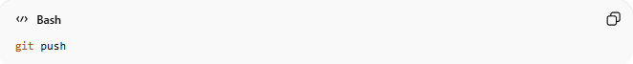
git push
Uploads your local commits from the current branch to the tracked remote branch.

🔹 2. Push to a Specific Branch (git push <remote> <branch>)
# Source: AI Source: Provided by: [Data Path: Persons Table -> ID Column: 1, Name_En Column: Motasem Essam] -> From: [Chatgpt (GPT‑5 Mini)] on [2/19/2026]
- Syntax:
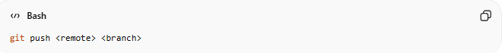
git push <remote> <branch>
- Description:
Pushes commits from your local branch to a specific branch on a specific remote repository.
Use this when you want to target a particular branch instead of the default upstream branch.
- Example:
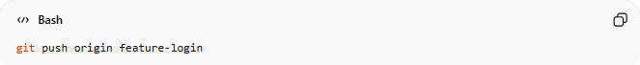
git push origin feature-login
Pushes the commits from your local feature-login branch to the feature-login branch on the remote repository origin.

Push Branches

🔹 1. Push a Specific Branch
# Source: AI Source: Provided by: [Data Path: Persons Table -> ID Column: 1, Name_En Column: Motasem Essam] -> From: [Chatgpt (GPT‑5 Mini)] on [2/19/2026]
- Syntax:
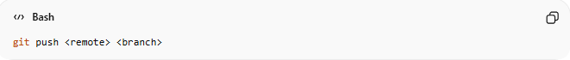
git push <remote> <branch>
- Description:
Pushes commits from your local branch to a specific branch on a specific remote.
Use this when you want to target a single branch.
- Example:
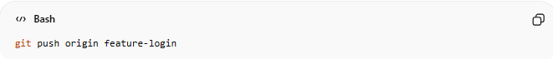
git push origin feature-login
Pushes the commits from your local feature-login branch to the feature-login branch on the remote origin.

🔹 2. Push All Branches
# Source: AI Source: Provided by: [Data Path: Persons Table -> ID Column: 1, Name_En Column: Motasem Essam] -> From: [Chatgpt (GPT‑5 Mini)] on [2/19/2026]
- Syntax:
git push --all <remote>
- Description:
Pushes all local branches to the remote repository at once.
Use this when you want to synchronize every branch with the remote.
- Example:
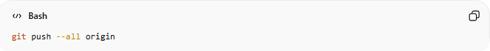
git push --all origin
Uploads all local branches to the origin remote, including main, feature-login, etc.

💡 Tip:
- Pushing all branches is useful in multi-branch workflows but can overwrite branches on the remote if not handled carefully.
- Always check git status or git branch -v before using --all.

Push Tags

🔹 1. Push a Specific Tag
# Source: AI Source: Provided by: [Data Path: Persons Table -> ID Column: 1, Name_En Column: Motasem Essam] -> From: [Chatgpt (GPT‑5 Mini)] on [2/19/2026]
- Syntax:
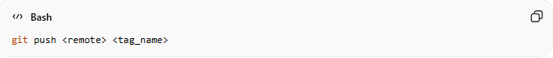
git push <remote> <tag_name>
- Description:
Pushes a single tag from your local repository to the remote repository.
Use this when you only want to share a specific version or release marker.
- Example:
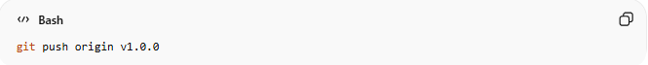
git push origin v1.0.0
Pushes the local tag v1.0.0 to the remote repository origin.

🔹 2. Push All Tags
# Source: AI Source: Provided by: [Data Path: Persons Table -> ID Column: 1, Name_En Column: Motasem Essam] -> From: [Chatgpt (GPT‑5 Mini)] on [2/19/2026]
- Syntax:
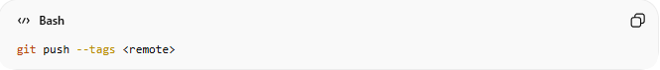
git push --tags <remote>
- Description:
Pushes all local tags to the remote repository at once.
Useful for sharing all version markers or release points in one command.
- Example:
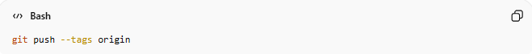
git push --tags origin
Uploads all local tags (v1.0.0, v1.1.0, etc.) to the remote origin.

💡 Tip:
- Tags are not automatically pushed with normal branch pushes.
- Use --tags or push specific tags when managing releases or versioning.

Force Push

🔹 1. Force Push to a Specific Branch (git push --force origin <branch_name>)
# Source: AI Source: Provided by: [Data Path: Persons Table -> ID Column: 1, Name_En Column: Motasem Essam] -> From: [Chatgpt (GPT‑5 Mini)] on [2/19/2026]
• Syntax:
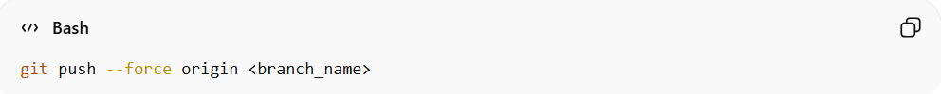
git push --force origin <branch_name>
• Explanation:
Forcefully pushes a specific local branch to a specific remote branch. Useful after rebasing or rewriting commits on a branch.
⚠️ Note: Be careful! This overwrites the remote branch history and can affect others collaborating on it.

• Example:
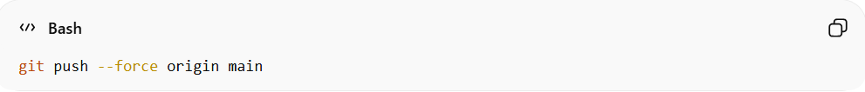
git push --force origin main
Force-pushes your local main branch to the remote origin/main, overwriting remote history.

🔹 2. Force Push (current branch) (git push --force)
# Source: AI Source: Provided by: [Data Path: Persons Table -> ID Column: 1, Name_En Column: Motasem Essam] -> From: [Chatgpt (GPT‑5 Mini)] on [2/19/2026]
3. Force Push (current branch) (git push --force)
• Syntax:
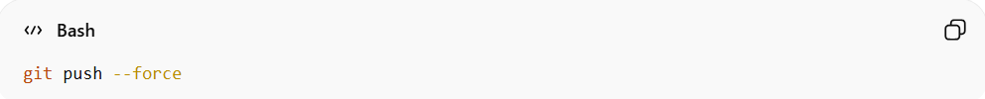
git push --force
• Explanation:
Forces the remote branch to match your local branch, overwriting remote changes.
⚠️ Note: Be careful! This will replace remote commits and can affect your team if others are working on the same branch.
• Example:
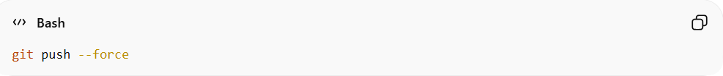
git push --force
Force-pushes your current branch to its tracked remote branch, replacing remote history.

Verify Remote Status
# Source: AI Source: Provided by: [Data Path: Persons Table -> ID Column: 1, Name_En Column: Motasem Essam] -> From: [Chatgpt (GPT‑5 Mini)] on [2/19/2026]
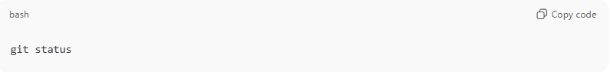
git status
- Confirms if your local branch is ahead of the remote or up to date.
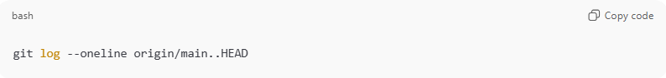
git log --oneline origin/main..HEAD
- Shows commits in your local branch that are not yet pushed to remote.

✅ Summary Table
# Source: AI Source: Provided by: [Data Path: Persons Table -> ID Column: 1, Name_En Column: Motasem Essam] -> From: [Chatgpt (GPT‑5 Mini)] on [2/19/2026]
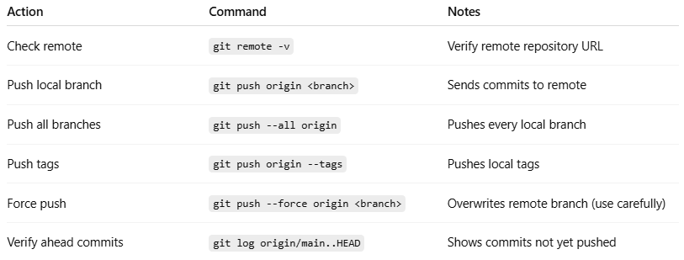
Action | Command | Notes
Check remote | git remote -v | Verify remote repository URL
Push local branch | git push origin <branch> | Sends commits to remote
Push all branches | git push --all origin | Pushes every local branch
Push tags | git push origin --tags | Pushes local tags
Force push | git push --force origin <branch> | Overwrites remote branch (use carefully)
Verify ahead commits | git log origin/main..HEAD | Shows commits not yet pushed

💡 Tip:
- Always pull (git pull) before pushing if others are working on the same branch to avoid conflicts.
- Use force push only after careful review to avoid overwriting others’ work.

Example

Add Remote Repository
# Source: ScreenShots Source: Provided by: [Persons Table -> ID Column: 1, Name_En Column: Motasem Essam] -> Tool: [Lightshot Program] -> From [Windows] on [2/19/2026]
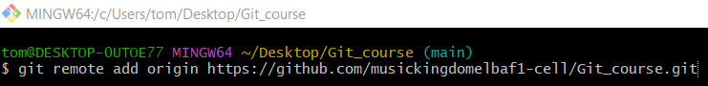
git remote add origin https://github.com/musickingdomelbaf1-cell/Git_course.git

Verify Remote URL
# Source: ScreenShots Source: Provided by: [Persons Table -> ID Column: 1, Name_En Column: Motasem Essam] -> Tool: [Lightshot Program] -> From [Windows] on [2/19/2026]
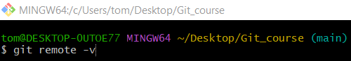
git remote -v
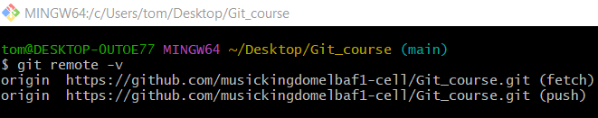

Set Upstream for Main

🔹 1. Set Upstream While Pushing (Push + Track)
# Source: ScreenShots Source: Provided by: [Persons Table -> ID Column: 1, Name_En Column: Motasem Essam] -> Tool: [Lightshot Program] -> From [Windows] on [2/19/2026]
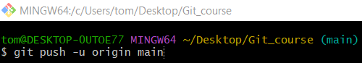
git push -u origin main
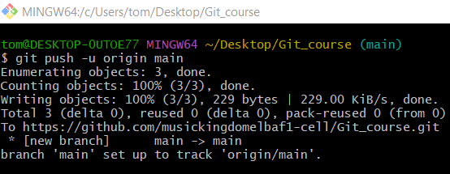

🔹 2. Set Upstream Manually (Without Pushing)
# Source: ScreenShots Source: Provided by: [Persons Table -> ID Column: 1, Name_En Column: Motasem Essam] -> Tool: [Lightshot Program] -> From [Windows] on [2/19/2026]
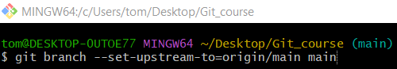
git branch --set-upstream-to=origin/main main
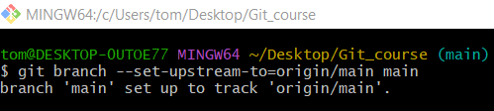

Upload Local Changes to Remote

Push files and folders

🔹 1. Normal Push (git push)
# Source: ScreenShots Source: Provided by: [Persons Table -> ID Column: 1, Name_En Column: Motasem Essam] -> Tool: [Lightshot Program] -> From [Windows] on [2/19/2026]
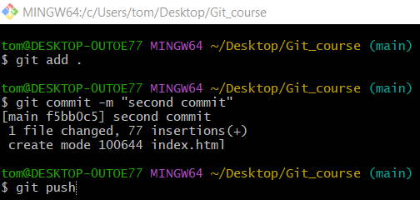
git push
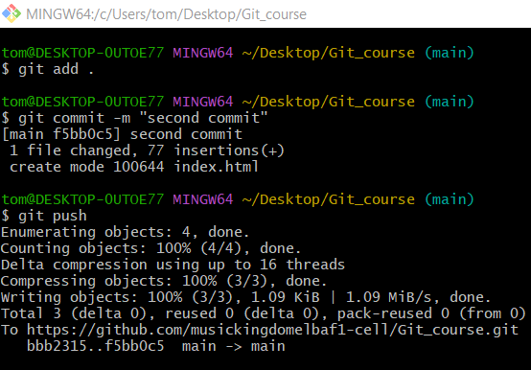

🔹 2. Push to a Specific Branch (git push <remote> <branch>)
# Source: ScreenShots Source: Provided by: [Persons Table -> ID Column: 1, Name_En Column: Motasem Essam] -> Tool: [Lightshot Program] -> From [Windows] on [2/19/2026]
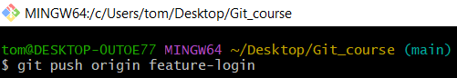
git push origin feature-login
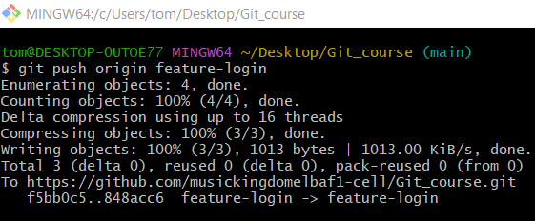

Push Branches

🔹 1. Push a Specific Branch
# Source: ScreenShots Source: Provided by: [Persons Table -> ID Column: 1, Name_En Column: Motasem Essam] -> Tool: [Lightshot Program] -> From [Windows] on [2/19/2026]
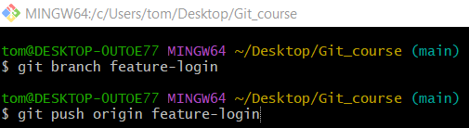
git push origin feature-login
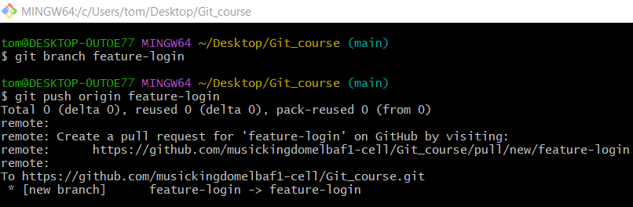

🔹 2. Push All Branches
# Source: ScreenShots Source: Provided by: [Persons Table -> ID Column: 1, Name_En Column: Motasem Essam] -> Tool: [Lightshot Program] -> From [Windows] on [2/19/2026]
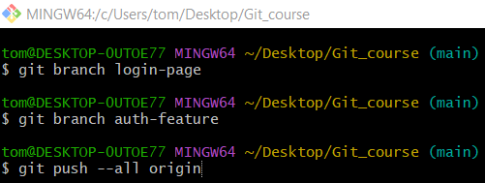
git push --all origin
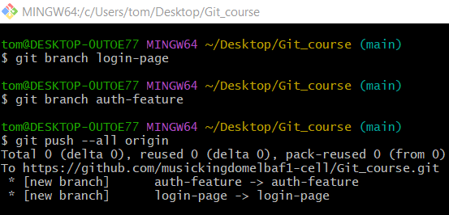

Push Tags

🔹 1. Push a Specific Tag
# Source: ScreenShots Source: Provided by: [Persons Table -> ID Column: 1, Name_En Column: Motasem Essam] -> Tool: [Lightshot Program] -> From [Windows] on [2/19/2026]
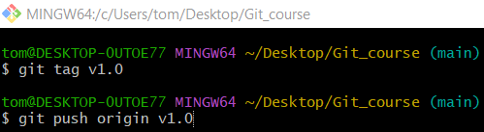
git push origin v1.0
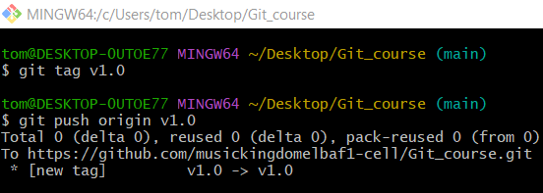

🔹 2. Push All Tags
# Source: ScreenShots Source: Provided by: [Persons Table -> ID Column: 1, Name_En Column: Motasem Essam] -> Tool: [Lightshot Program] -> From [Windows] on [2/19/2026]
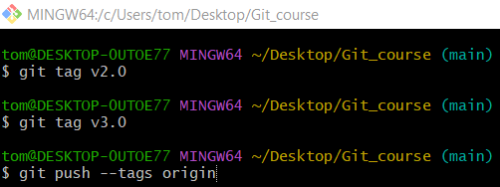
git push --tags origin
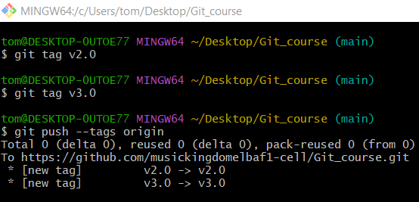

Force Push

🔹 1. Force Push to a Specific Branch (git push --force origin <branch_name>)
# Source: ScreenShots Source: Provided by: [Persons Table -> ID Column: 1, Name_En Column: Motasem Essam] -> Tool: [Lightshot Program] -> From [Windows] on [2/19/2026]
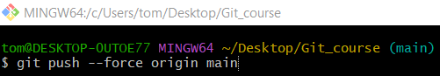
git push --force origin main

🔹 2. Force Push (current branch) (git push --force)
# Source: ScreenShots Source: Provided by: [Persons Table -> ID Column: 1, Name_En Column: Motasem Essam] -> Tool: [Lightshot Program] -> From [Windows] on [2/19/2026]
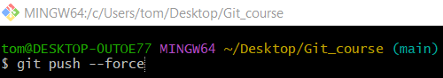
git push --force

Verify Remote Status
# Source: ScreenShots Source: Provided by: [Persons Table -> ID Column: 1, Name_En Column: Motasem Essam] -> Tool: [Lightshot Program] -> From [Windows] on [2/19/2026]
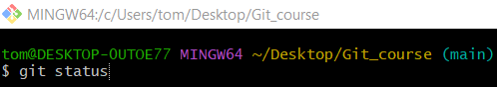
git status
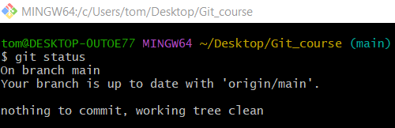
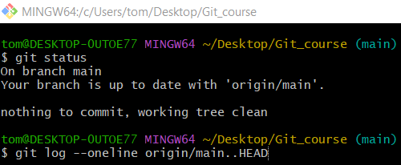
git log --oneline origin/main..HEAD
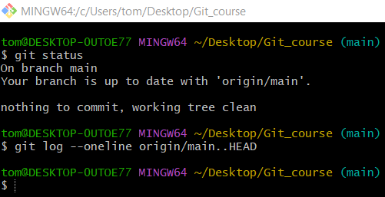

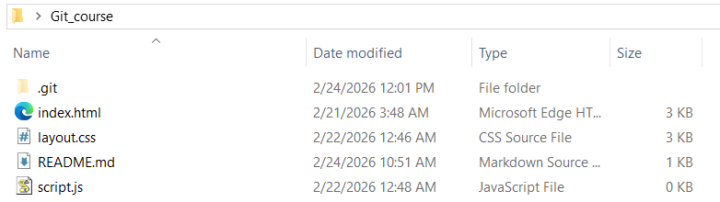
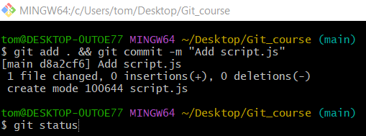
git status
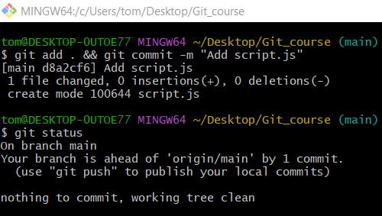
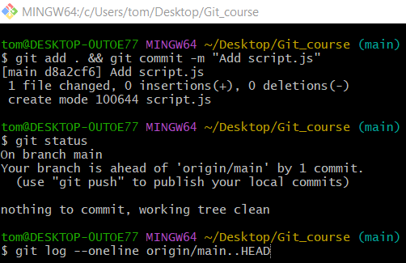
git log --oneline origin/main..HEAD
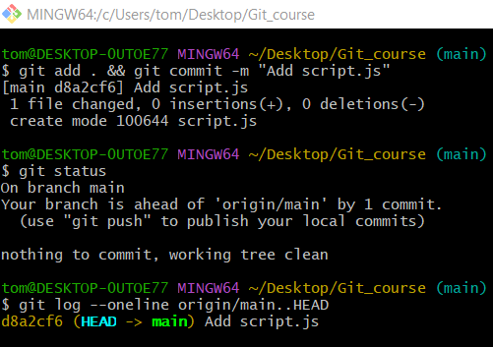

git push to GDW

Step 1 git add
# Source: ScreenShots Source: Provided by: [Persons Table -> ID Column: 1, Name_En Column: Motasem Essam] -> Tool: [Lightshot Program] -> From [Windows] on [2/19/2026]
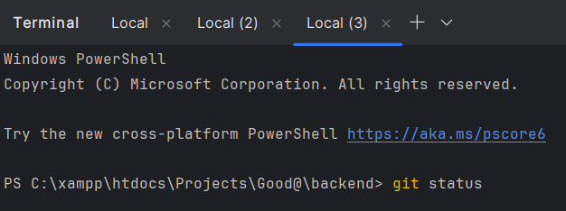
git status
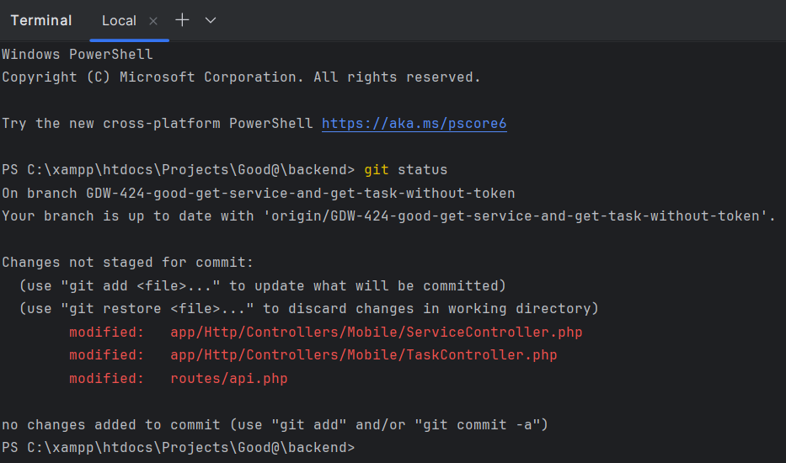
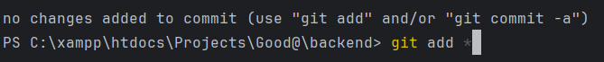
git add *

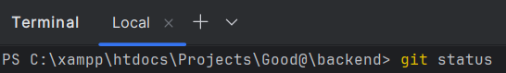
git status
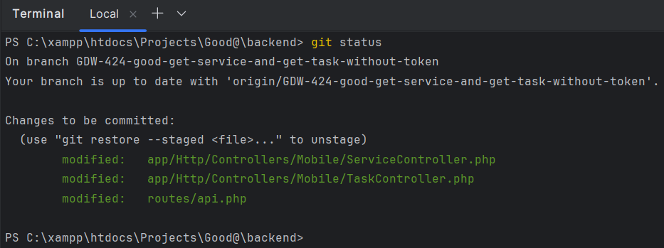

Step 2 git commit
# Source: ScreenShots Source: Provided by: [Persons Table -> ID Column: 1, Name_En Column: Motasem Essam] -> Tool: [Lightshot Program] -> From [Windows] on [2/19/2026]
git commit -m "GDW-424 fix get service and task without token"
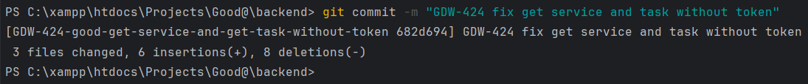

Step 3 git push
# Source: ScreenShots Source: Provided by: [Persons Table -> ID Column: 1, Name_En Column: Motasem Essam] -> Tool: [Lightshot Program] -> From [Windows] on [2/19/2026]
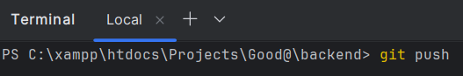
git push

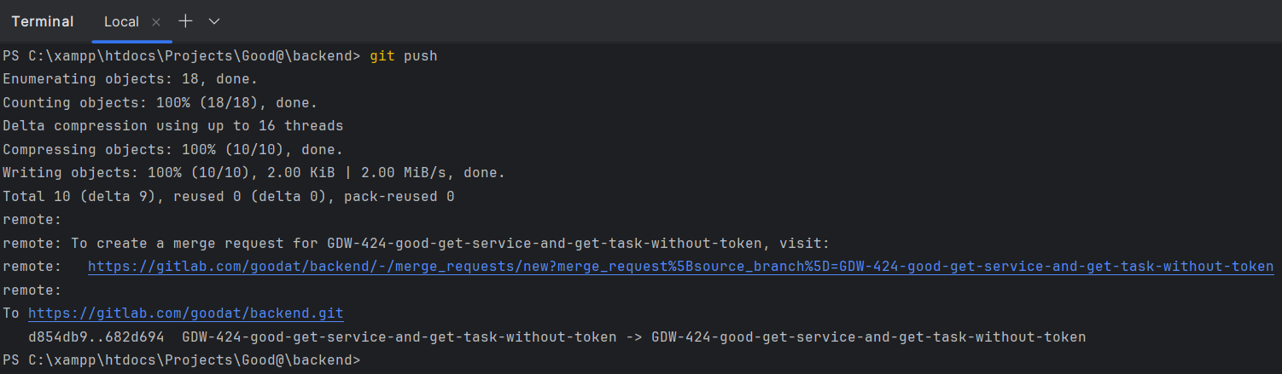

Step 4 check Jira
# Source: ScreenShots Source: Provided by: [Persons Table -> ID Column: 1, Name_En Column: Motasem Essam] -> Tool: [Lightshot Program] -> From [Windows] on [2/19/2026]
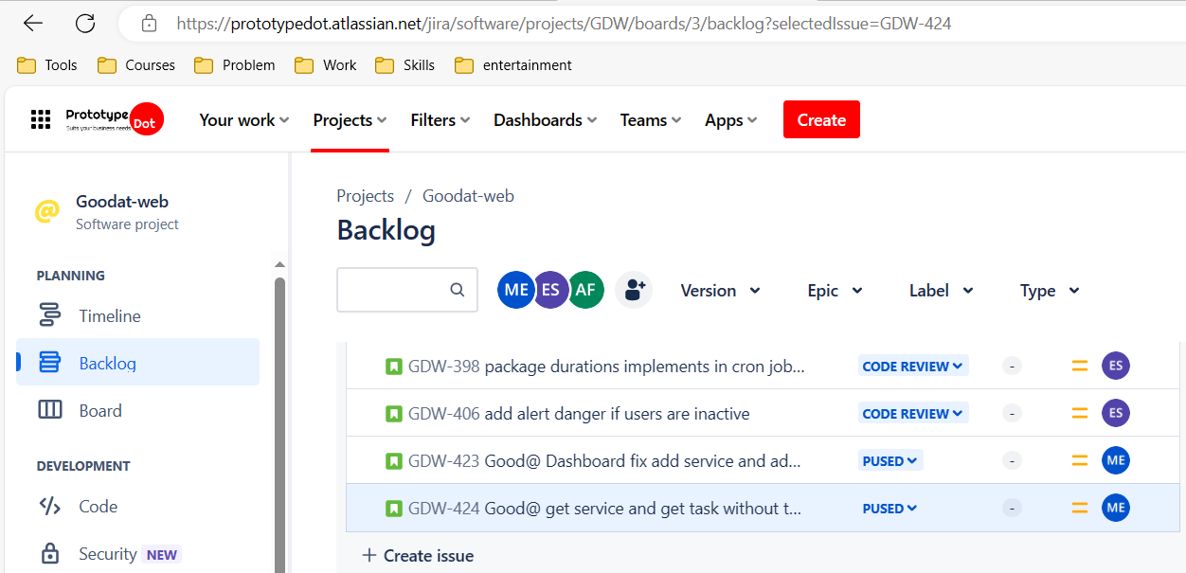

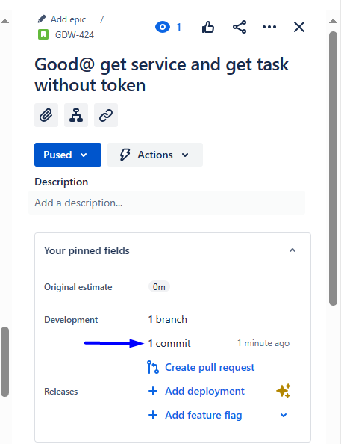
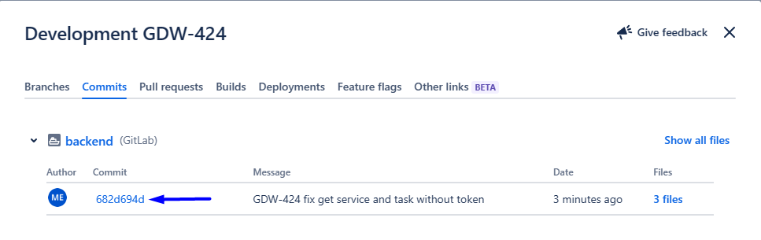
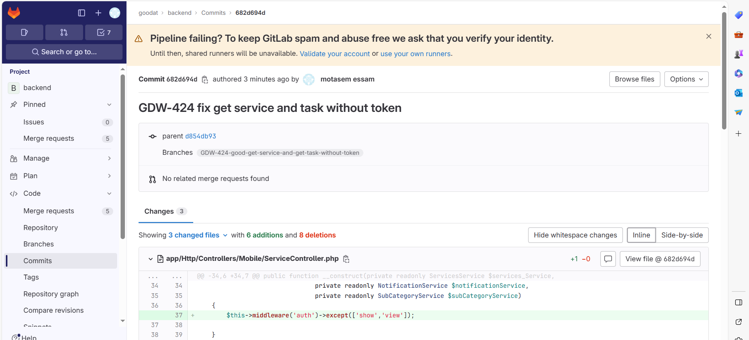

From Remote repository to Local repository and Workspace
# Source: AI Source: Provided by: [Data Path: Persons Table -> ID Column: 1, Name_En Column: Motasem Essam] -> From: [Chatgpt (GPT‑5 Mini)] on [2/19/2026]
Got it 👍 — here is a clean section you can add to your topic.
This means bringing changes from the remote repo (e.g., GitHub) into your local repo and Workspace.
There are 2 main ways: pull and fetch

Download Local Changes from Remote

🔹 1. git pull – Pull Changes

🔹 1. Normal Pull (git pull)
# Source: AI Source: Provided by: [Data Path: Persons Table -> ID Column: 1, Name_En Column: Motasem Essam] -> From: [Chatgpt (GPT‑5 Mini)] on [2/19/2026]
- Syntax:
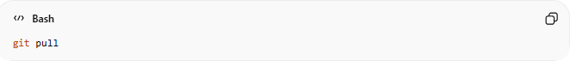
git pull
- Explanation:
Fetches changes from the remote branch your current local branch is tracking (upstream) and merges them automatically into your local branch.
Use this when you just want to update your current branch from its remote counterpart.
- What it does:
- Downloads changes from the tracked remote branch.
- Merges them into your local branch.
- Updates files in your workspace immediately.
So the flow is:
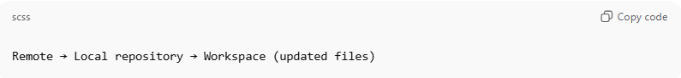
Remote → Local repository → Workspace (updated files)

- Example:
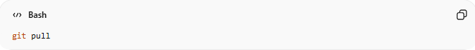
git pull
Pulls and merges changes from the tracked remote branch of your current local branch.

🔹 2. Pull from a Specific Branch (git pull <remote> <branch>)
# Source: AI Source: Provided by: [Data Path: Persons Table -> ID Column: 1, Name_En Column: Motasem Essam] -> From: [Chatgpt (GPT‑5 Mini)] on [2/19/2026]
- Syntax:
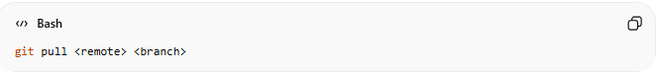
git pull <remote> <branch>
- Explanation:
Fetches changes from a specific branch on a specific remote repository and merges them into your current local branch.
Use this when you want to update your branch from a remote branch that may not be the default upstream.
- Example:
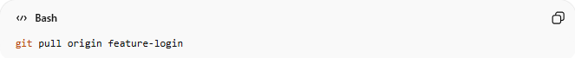
git pull origin feature-login
Pulls and merges changes from the feature-login branch on the origin remote into your current local branch.

🔹 3. Pull Specific File or Folder
# Source: AI Source: Provided by: [Data Path: Persons Table -> ID Column: 1, Name_En Column: Motasem Essam] -> From: [Chatgpt (GPT‑5 Mini)] on [2/19/2026]
- Syntax:
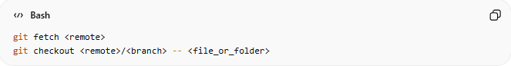
git fetch <remote>
git checkout <remote>/<branch> -- <file_or_folder>
- Explanation:
- git fetch <remote> → Downloads changes from the remote repository without merging anything.
- git checkout <remote>/<branch> -- <file_or_folder> → Updates only the specific file(s) or folder(s) in your local workspace from the remote branch.
- This is useful when you want to update certain files without affecting your entire branch.
- Example:
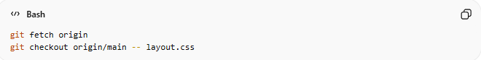
git fetch origin
git checkout origin/main -- layout.css
Updates only layout.css in your local workspace with the version from the main branch on the origin remote.
Other files in your branch remain unchanged.

💡 Tip:
- After pulling a specific file, you may need to commit if you want to save it permanently in your branch:
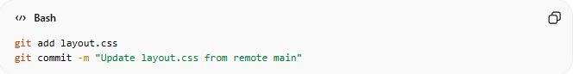
git add layout.css
git commit -m "Update layout.css from remote main"

If you want, I can now combine all three pull types (normal, specific branch, specific file/folder) into a single polished cheat-sheet section just like your push commands.
Do you want me to do that?

🔹 2. git fetch – Fetch Only

🔹 1. Git Fetch - Download Remote Changes without Merging
# Source: AI Source: Provided by: [Data Path: Persons Table -> ID Column: 1, Name_En Column: Motasem Essam] -> From: [Chatgpt (GPT‑5 Mini)] on [2/19/2026]
- Syntax (Simple Fetch):
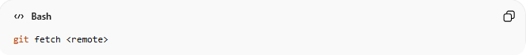
git fetch <remote>
- Explanation:
Downloads changes from the remote repository without merging them into your current branch.
This allows you to review incoming changes before applying them.
- Example:
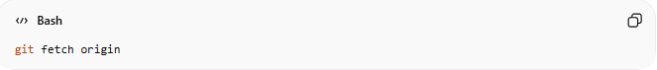
git fetch origin
Fetches all updates from the remote repository origin but keeps your current branch unchanged.

🔹 2. Git Fetch - Download Remote Changes with Merging
# Source: AI Source: Provided by: [Data Path: Persons Table -> ID Column: 1, Name_En Column: Motasem Essam] -> From: [Chatgpt (GPT‑5 Mini)] on [2/19/2026]
⚡ Fetch First, Then Update Workspace Manually
Sometimes you want to control when changes are applied:
- Syntax:
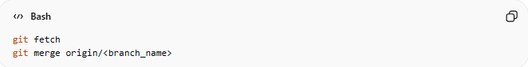
git fetch
git merge origin/<branch_name>
- What Happens:
- git fetch → Downloads remote changes (does not touch your workspace).
- git merge origin/<branch_name> → Applies the changes; your local workspace is updated.
- Example:
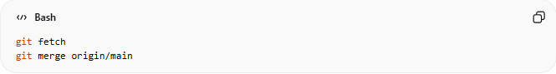
git fetch
git merge origin/main
First fetches all remote updates, then merges the main branch into your current branch manually.

🔹 3. Switch Workspace to Remote Version (Overwrite Local Files)
# Source: AI Source: Provided by: [Data Path: Persons Table -> ID Column: 1, Name_En Column: Motasem Essam] -> From: [Chatgpt (GPT‑5 Mini)] on [2/19/2026]
If you want your workspace to match the remote exactly:
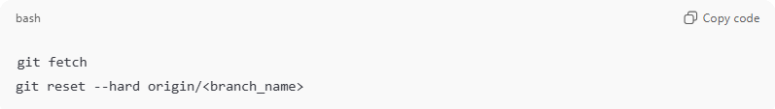
git fetch
git reset --hard origin/<branch_name>
Example:
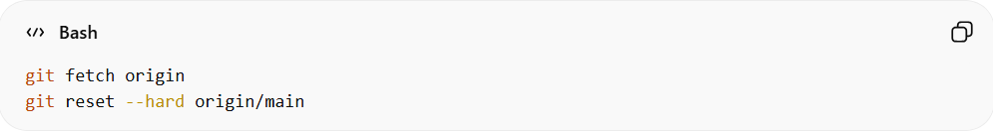
git fetch origin
git reset --hard origin/main
⚠ Warning:
- This overwrites your workspace and local changes.
- Use only if you want to discard local modifications.

🔹 4. Restore a Single File from Remote to Workspace
# Source: AI Source: Provided by: [Data Path: Persons Table -> ID Column: 1, Name_En Column: Motasem Essam] -> From: [Chatgpt (GPT‑5 Mini)] on [2/19/2026]
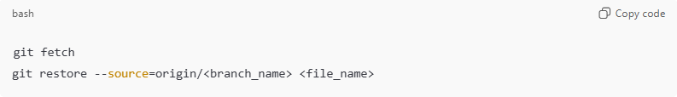
git fetch
git restore --source=origin/<branch_name> <file_name>
Example:
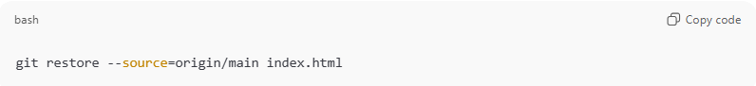
git restore --source=origin/main index.html
- Updates only that file in your workspace from remote.

Merge Conflict
# Source: AI Source: Provided by: [Data Path: Persons Table -> ID Column: 1, Name_En Column: Motasem Essam] -> From: [Chatgpt (GPT‑5 Mini)] on [2/19/2026]
If both local and remote changed the same lines:
- Git stops and asks you to resolve conflicts.
- After fixing:
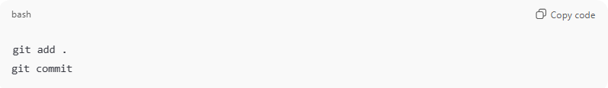
git add .
git commit

Quick Summary
# Source: AI Source: Provided by: [Data Path: Persons Table -> ID Column: 1, Name_En Column: Motasem Essam] -> From: [Chatgpt (GPT‑5 Mini)] on [2/19/2026]
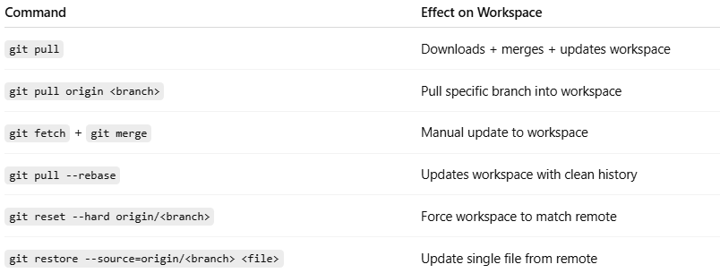
Command | Effect on Workspace
git pull | Downloads + merges + updates workspace
git pull origin <branch> | Pull specific branch into workspace
git fetch + git merge | Manual update to workspace
git pull --rebase | Updates workspace with clean history
git reset --hard origin/<branch> | Force workspace to match remote
git restore --source=origin/<branch> <file> | Update single file from remote

Simple Flow
# Source: AI Source: Provided by: [Data Path: Persons Table -> ID Column: 1, Name_En Column: Motasem Essam] -> From: [Chatgpt (GPT‑5 Mini)] on [2/19/2026]
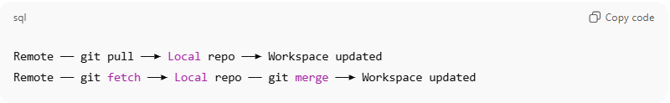
Remote ── git pull ──► Local repo ──► Workspace updated
Remote ── git fetch ──► Local repo ── git merge ──► Workspace updated

Example

Download Local Changes from Remote

🔹 1. git pull – Pull Changes

🔹 1. Normal Pull (git pull)
# Source: ScreenShots Source: Provided by: [Persons Table -> ID Column: 1, Name_En Column: Motasem Essam] -> Tool: [Lightshot Program] -> From [Site: https://github.com] on [2/17/2026]
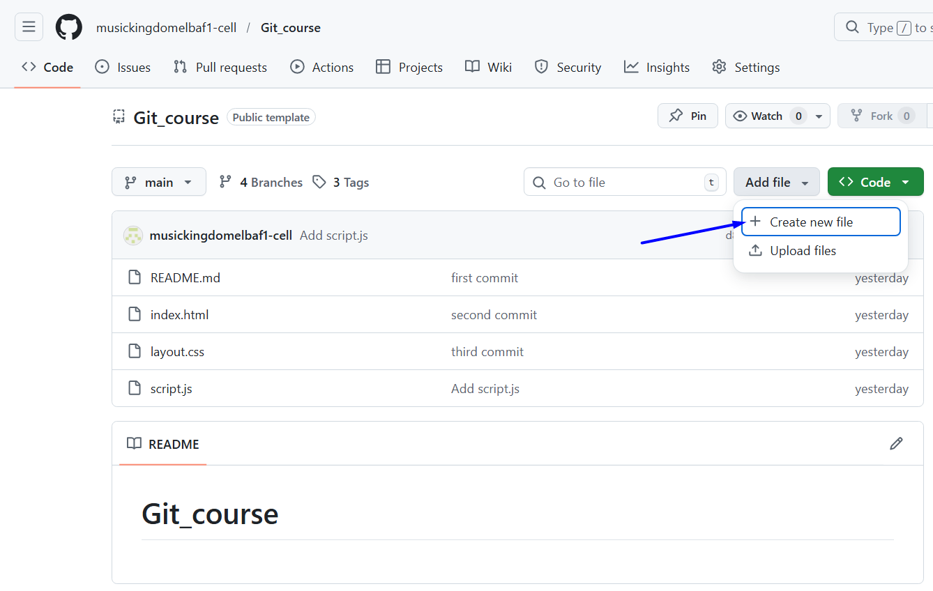
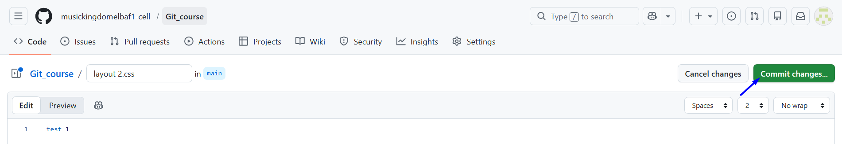
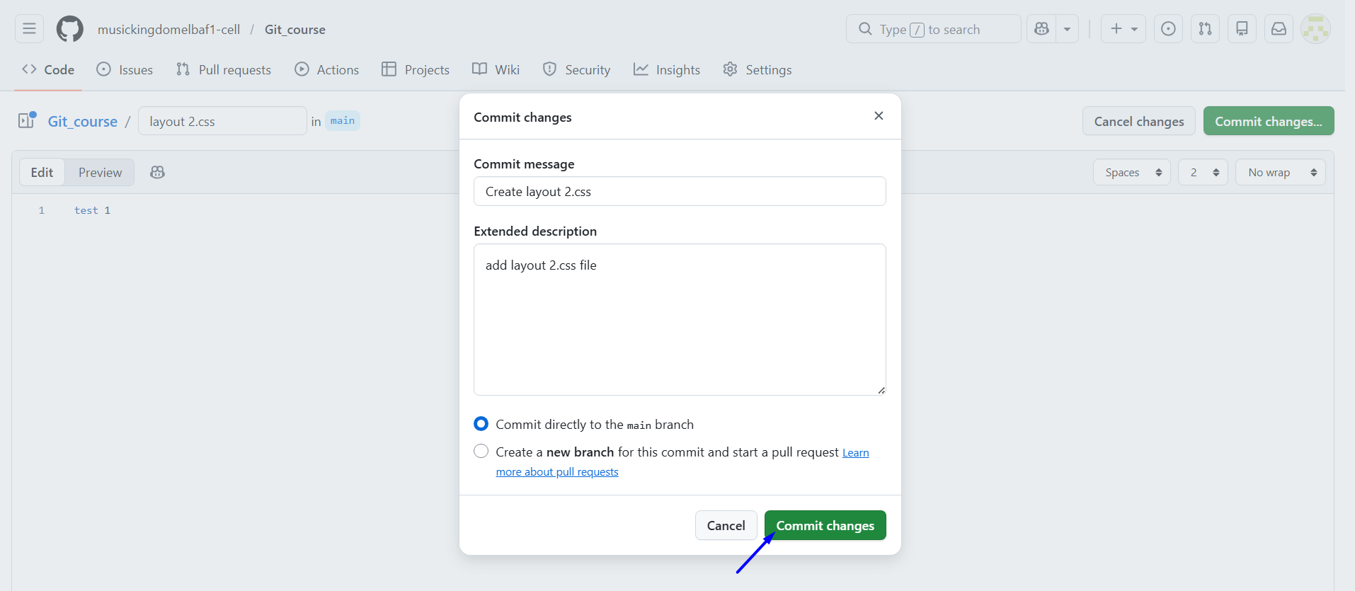
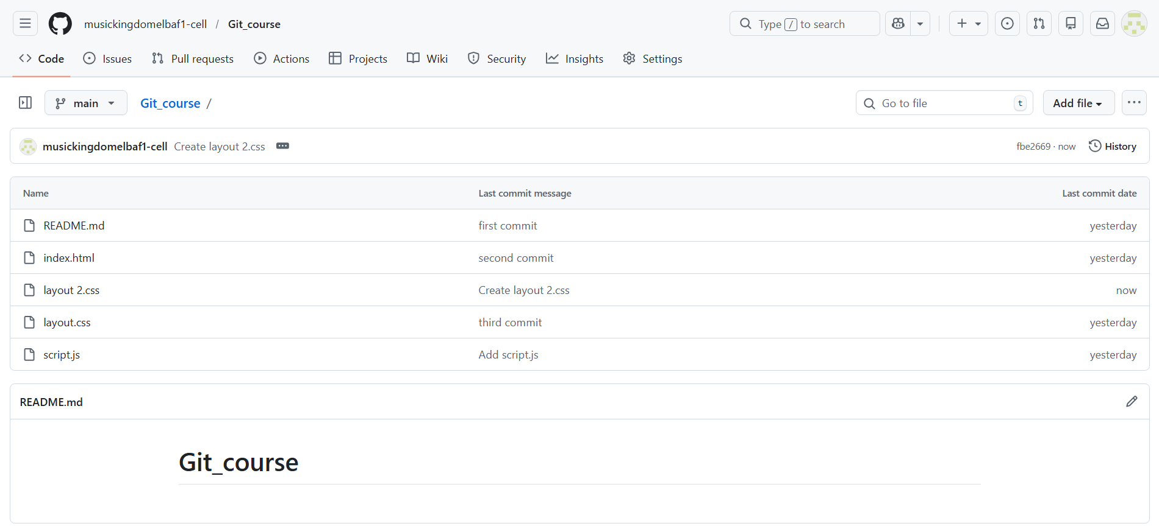

# Source: ScreenShots Source: Provided by: [Persons Table -> ID Column: 1, Name_En Column: Motasem Essam] -> Tool: [Lightshot Program] -> From [Windows] on [2/19/2026]
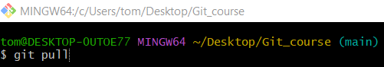
git pull
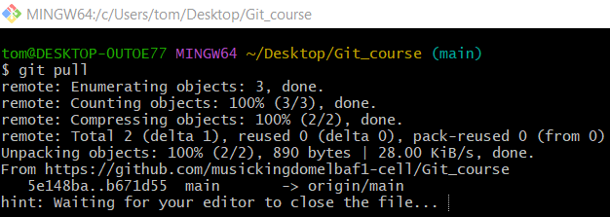
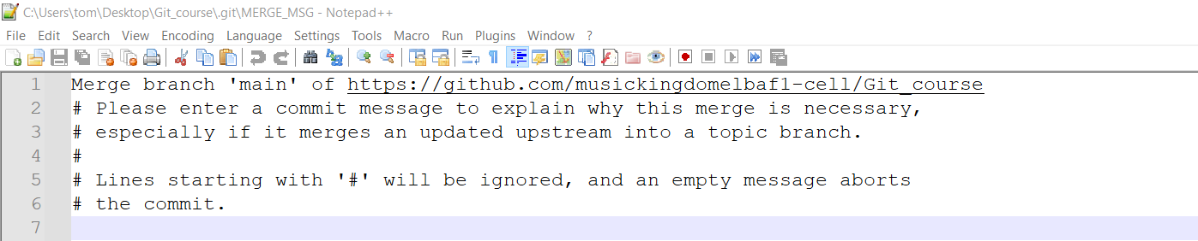
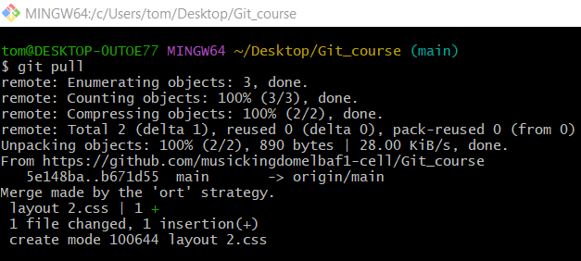

🔹 2. Pull from a Specific Branch (git pull <remote> <branch>)
# Source: ScreenShots Source: Provided by: [Persons Table -> ID Column: 1, Name_En Column: Motasem Essam] -> Tool: [Lightshot Program] -> From [Site: https://github.com] on [2/17/2026]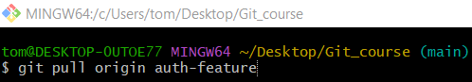
git pull origin auth-feature
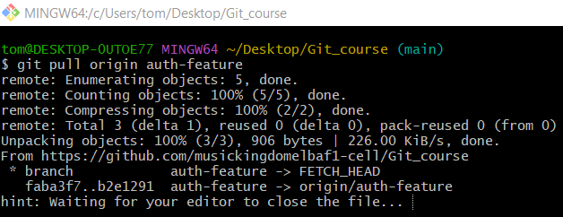
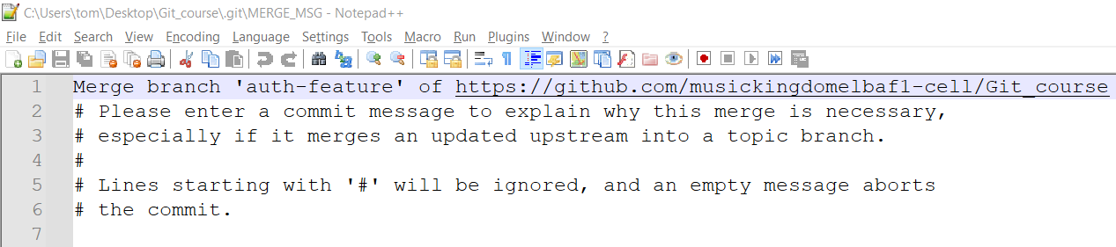
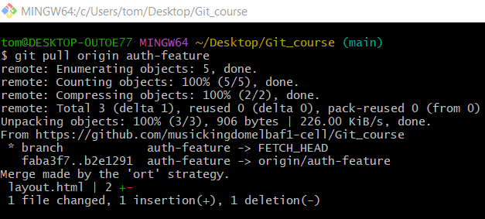

🔹 3. Pull Specific File or Folder
# Source: ScreenShots Source: Provided by: [Persons Table -> ID Column: 1, Name_En Column: Motasem Essam] -> Tool: [Lightshot Program] -> From [Site: https://github.com] on [2/17/2026]
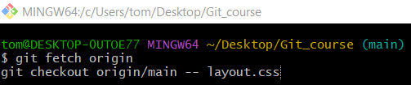
git fetch origin
git checkout origin/main -- layout.css
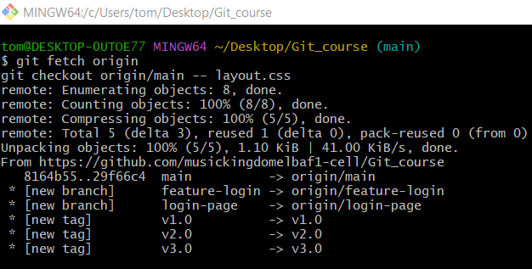

🔹 2. git fetch – Fetch Only

🔹 1. Git Fetch - Download Remote Changes without Merging
# Source: ScreenShots Source: Provided by: [Persons Table -> ID Column: 1, Name_En Column: Motasem Essam] -> Tool: [Lightshot Program] -> From [Site: https://github.com] on [2/17/2026]
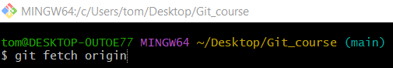
git fetch origin
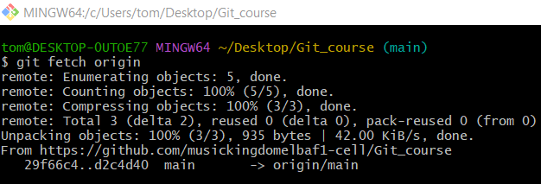

🔹 2. Git Fetch - Download Remote Changes with Merging
# Source: ScreenShots Source: Provided by: [Persons Table -> ID Column: 1, Name_En Column: Motasem Essam] -> Tool: [Lightshot Program] -> From [Site: https://github.com] on [2/17/2026]
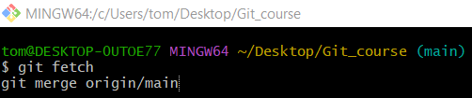
git fetch
git merge origin/main
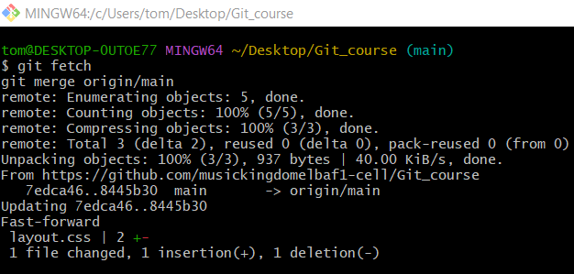

🔹 3. Switch Workspace to Remote Version (Overwrite Local Files)
# Source: ScreenShots Source: Provided by: [Persons Table -> ID Column: 1, Name_En Column: Motasem Essam] -> Tool: [Lightshot Program] -> From [Site: https://github.com] on [2/17/2026]
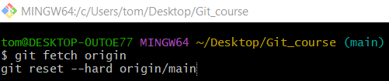
git fetch origin
git reset --hard origin/main
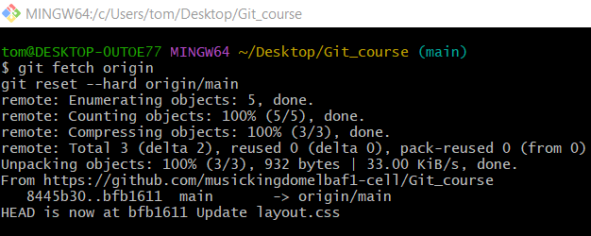

🔹 4. Restore a Single File from Remote to Workspace
# Source: ScreenShots Source: Provided by: [Persons Table -> ID Column: 1, Name_En Column: Motasem Essam] -> Tool: [Lightshot Program] -> From [Site: https://github.com] on [2/17/2026]
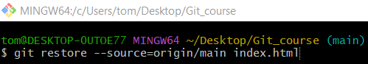
git restore --source=origin/main index.html

Errors

refusing to merge unrelated histories at Normal Pull (git pull) and Pull from a Specific Branch

Error
# Source: ScreenShots Source: Provided by: [Persons Table -> ID Column: 1, Name_En Column: Motasem Essam] -> Tool: [Lightshot Program] -> From [Windows] on [2/19/2026]
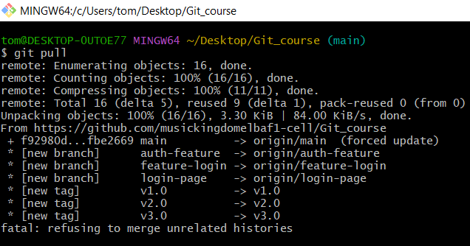

Solve 1
# Source: ScreenShots Source: Provided by: [Persons Table -> ID Column: 1, Name_En Column: Motasem Essam] -> Tool: [Lightshot Program] -> From [Windows] on [2/19/2026]
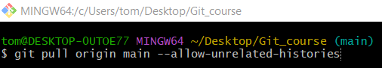
git pull origin main --allow-unrelated-histories
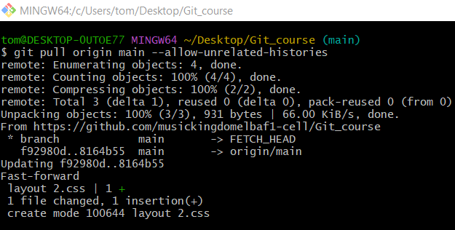
# Source: AI Source: Provided by: [Data Path: Persons Table -> ID Column: 1, Name_En Column: Motasem Essam] -> From: [Chatgpt (GPT‑5 Mini)] on [2/19/2026]
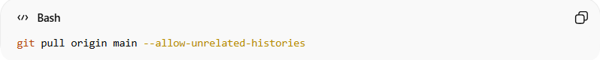
git pull origin main --allow-unrelated-histories

breakdown:
- git pull → fetch and merge changes from remote
- origin → the remote repository (GitHub)
- main → the branch to pull
- --allow-unrelated-histories → merge even if local and remote have no common history
✅ Updates your local branch with remote changes, even if the histories are unrelated.

Solve 2
# Source: ScreenShots Source: Provided by: [Persons Table -> ID Column: 1, Name_En Column: Motasem Essam] -> Tool: [Lightshot Program] -> From [Windows] on [2/19/2026]
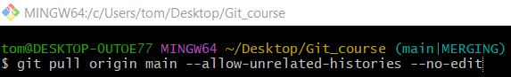
git pull origin main --allow-unrelated-histories --no-edit
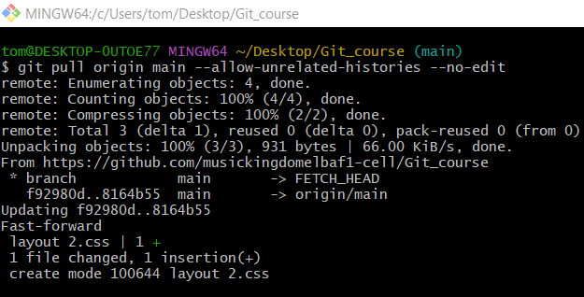
# Source: AI Source: Provided by: [Data Path: Persons Table -> ID Column: 1, Name_En Column: Motasem Essam] -> From: [Chatgpt (GPT‑5 Mini)] on [2/19/2026]
git pull origin main --allow-unrelated-histories --no-edit

breakdown:
- git pull → fetch & merge remote changes
- origin → remote repository
- main → branch to pull
- --allow-unrelated-histories → merge even if histories don’t match
- --no-edit → use default merge message automatically
✅ Pulls and merges changes in one step without opening the editor.
Git automatically uses the standard merge message:
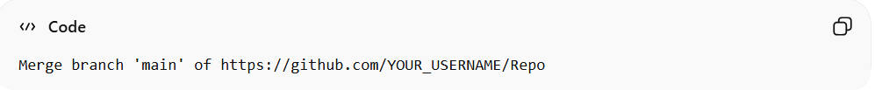
Merge branch 'main' of https://github.com/YOUR_USERNAME/Repo

local changes would be overwritten

Error
# Source: ScreenShots Source: Provided by: [Persons Table -> ID Column: 1, Name_En Column: Motasem Essam] -> Tool: [Lightshot Program] -> From [Windows] on [2/19/2026]
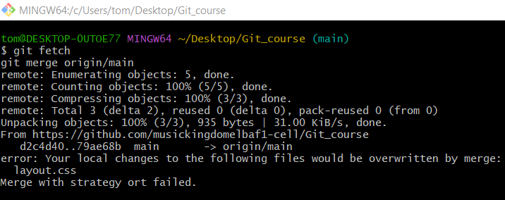

Solve 1: Keep Local Changes (Stash Them)
# Source: AI Source: Provided by: [Data Path: Persons Table -> ID Column: 1, Name_En Column: Motasem Essam] -> From: [Chatgpt (GPT‑5 Mini)] on [2/19/2026]
- Stash your changes temporarily:
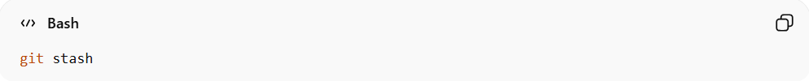
git stash
- This saves your changes and clears your working directory.
- Pull the remote changes safely:
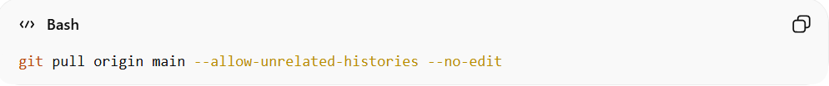
git pull origin main --allow-unrelated-histories --no-edit
- Apply your stashed changes back:
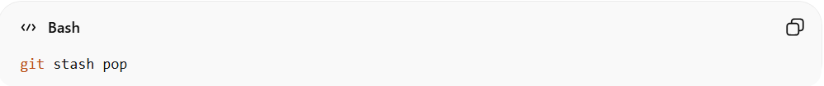
git stash pop
If there are conflicts, Git will ask you to resolve them.

Solve 2: Commit Your Local Changes
# Source: AI Source: Provided by: [Data Path: Persons Table -> ID Column: 1, Name_En Column: Motasem Essam] -> From: [Chatgpt (GPT‑5 Mini)] on [2/19/2026]
- Add your changes:
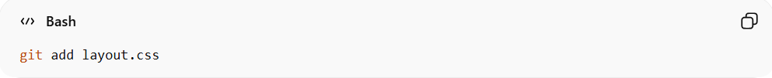
git add layout.css
- Commit them:
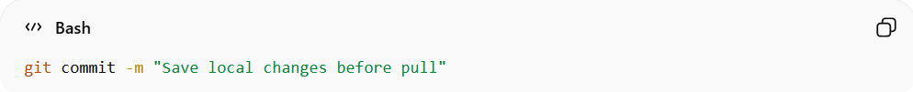
git commit -m "Save local changes before pull"
- Pull remote changes:
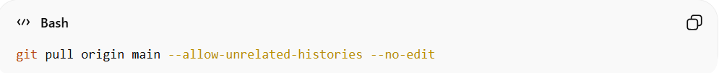
git pull origin main --allow-unrelated-histories --no-edit
Git will merge your commit with the remote changes.

Solve 3: Discard Local Changes (Dangerous)
# Source: AI Source: Provided by: [Data Path: Persons Table -> ID Column: 1, Name_En Column: Motasem Essam] -> From: [Chatgpt (GPT‑5 Mini)] on [2/19/2026]
Only if you don’t need your local changes.
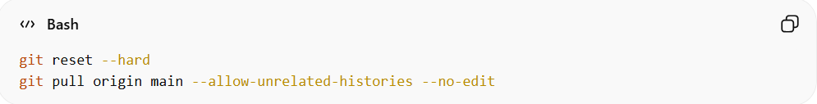
git reset --hard
git pull origin main --allow-unrelated-histories --no-edit
- git reset --hard deletes all uncommitted changes permanently.

The remote main branch has commits that your local main does NOT have.

Error
# Source: ScreenShots Source: Provided by: [Persons Table -> ID Column: 1, Name_En Column: Motasem Essam] -> Tool: [Lightshot Program] -> From [Windows] on [2/19/2026]
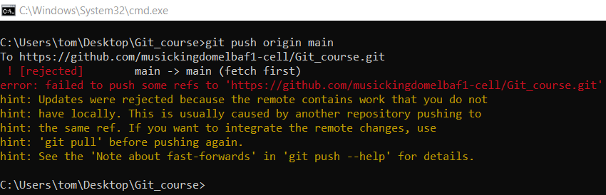
# Source: AI Source: Provided by: [Data Path: Persons Table -> ID Column: 1, Name_En Column: Motasem Essam] -> From: [Chatgpt (GPT‑5 Mini)] on [2/19/2026]
This error happens because:
🚫 The remote main branch has commits that your local main does NOT have.
Git is protecting you from overwriting changes on GitHub.
🧠 Why This Happened
Someone (or GitHub itself) added something to the repo, like:
- README file
- License
- Another commit from another machine
So now:
Remote main ≠ Local main
Git requires you to sync first.

Solve 1
# Source: AI Source: Provided by: [Data Path: Persons Table -> ID Column: 1, Name_En Column: Motasem Essam] -> From: [Chatgpt (GPT‑5 Mini)] on [2/19/2026]
✅ ✅ SAFE FIX (Recommended)
Step 1️⃣ Pull the latest changes first
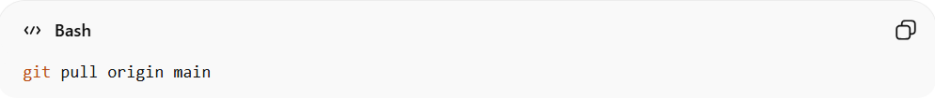
git pull origin main
This will:
- Download remote commits
- Merge them into your local main

Step 2️⃣ If there are conflicts
Resolve them manually → then:
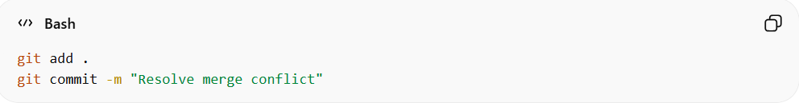
git add .
git commit -m "Resolve merge conflict"

Step 3️⃣ Push again
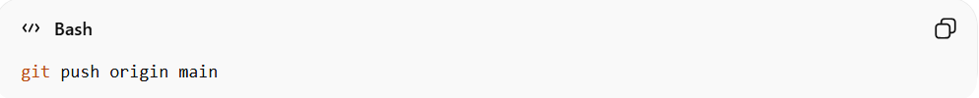
git push origin main
✅ This should now work.

Solve 2
# Source: AI Source: Provided by: [Data Path: Persons Table -> ID Column: 1, Name_En Column: Motasem Essam] -> From: [Chatgpt (GPT‑5 Mini)] on [2/19/2026]
🔥 Cleaner Option (Rebase – Better History)
Instead of merge:
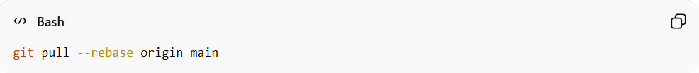
git pull --rebase origin main
Then push:
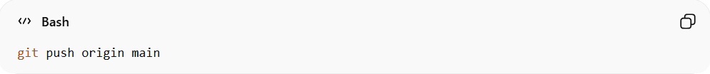
git push origin main
This keeps history clean.

Solve 3
# Source: AI Source: Provided by: [Data Path: Persons Table -> ID Column: 1, Name_En Column: Motasem Essam] -> From: [Chatgpt (GPT‑5 Mini)] on [2/19/2026]
⚠️ Dangerous Option (Only If You Are 100% Sure)
If you want to overwrite the remote branch completely:
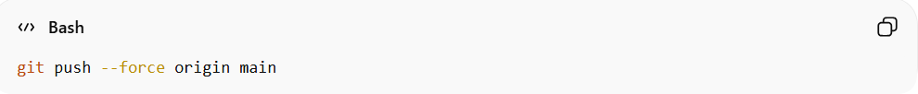
git push --force origin main
⚠️ This will delete remote commits that you don’t have locally.
Use this only if:
- You know the remote changes are not needed
- Or it's your personal repo

Solve 4
# Source: AI Source: Provided by: [Data Path: Persons Table -> ID Column: 1, Name_En Column: Motasem Essam] -> From: [Chatgpt (GPT‑5 Mini)] on [2/19/2026]
🏆 Best Practice
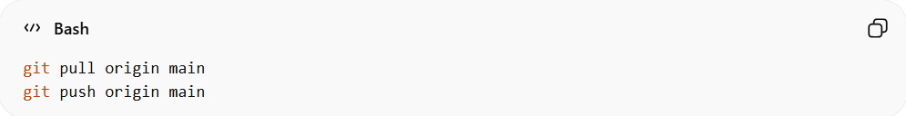
Always do this before pushing to main:
git pull origin main
git push origin main

Pull Request
# Source: AI Source: Provided by: [Data Path: Persons Table -> ID Column: 1, Name_En Column: Motasem Essam] -> From: [Chatgpt (GPT‑5 Mini)] on [2/19/2026]
A Pull Request (PR) is a core feature in Git platforms like GitHub and GitLab. It’s how you propose changes from one branch to another and get them reviewed before merging. Think of it as asking: “Hey team, I’ve made some changes—can we merge them into the main branch?”
Here’s a complete guide:

What is a Pull Request?
# Source: AI Source: Provided by: [Data Path: Persons Table -> ID Column: 1, Name_En Column: Motasem Essam] -> From: [Chatgpt (GPT‑5 Mini)] on [2/19/2026]
- A Pull Request (PR) is a request to merge changes from one branch (usually your feature branch) into another branch (usually main or master) in a repository.
- Key purposes:
  - Code Review: Other team members can check your code before merging.
  - Discussion: You can discuss improvements or potential issues.
  - Integration: Ensures your changes don’t break the main branch before merging.

Steps to Create a Pull Request

Step 1: Create a Feature Branch
# Source: AI Source: Provided by: [Data Path: Persons Table -> ID Column: 1, Name_En Column: Motasem Essam] -> From: [Chatgpt (GPT‑5 Mini)] on [2/19/2026]
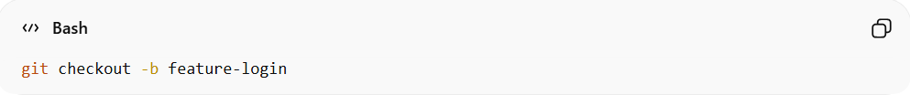
git checkout -b feature-login
- Never work directly on main; create a new branch for your changes.

Step 2: Make Changes and Commit
# Source: AI Source: Provided by: [Data Path: Persons Table -> ID Column: 1, Name_En Column: Motasem Essam] -> From: [Chatgpt (GPT‑5 Mini)] on [2/19/2026]
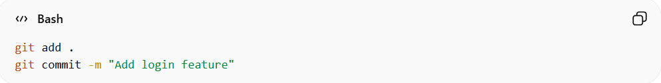
git add .
git commit -m "Add login feature"
- Commit logically grouped changes with clear messages.

Step 3: Push Your Branch to Remote
# Source: AI Source: Provided by: [Data Path: Persons Table -> ID Column: 1, Name_En Column: Motasem Essam] -> From: [Chatgpt (GPT‑5 Mini)] on [2/19/2026]
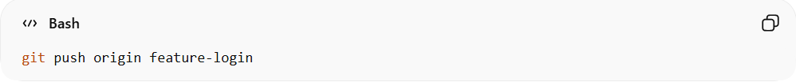
git push origin feature-login
- Uploads your local feature branch to the remote repository.

Step 4: Open a Pull Request
# Source: AI Source: Provided by: [Data Path: Persons Table -> ID Column: 1, Name_En Column: Motasem Essam] -> From: [Chatgpt (GPT‑5 Mini)] on [2/19/2026]
On GitHub or GitLab UI:
- Go to the repository on the website.
- Navigate to the Pull Requests (GitHub) or Merge Requests (GitLab) tab.
- Click New Pull Request (GitHub) or New Merge Request (GitLab).
- Select:
  - Source branch: Your feature branch (feature-login)
  - Target branch: Usually main or develop
- Add a title and description explaining your changes.
- Assign reviewers (optional but recommended).
- Click Create Pull Request (GitHub) / Submit Merge Request (GitLab).

Step 5: Review & Merge
# Source: AI Source: Provided by: [Data Path: Persons Table -> ID Column: 1, Name_En Column: Motasem Essam] -> From: [Chatgpt (GPT‑5 Mini)] on [2/19/2026]
- Team members review, comment, and approve the PR.
- Once approved, you or the reviewer can merge it into the target branch.
Optional: If there are conflicts, you may need to:
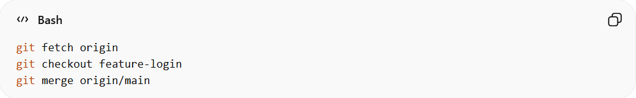
git fetch origin
git checkout feature-login
git merge origin/main
Resolve conflicts, commit, then push again.

Quick Notes
# Source: AI Source: Provided by: [Data Path: Persons Table -> ID Column: 1, Name_En Column: Motasem Essam] -> From: [Chatgpt (GPT‑5 Mini)] on [2/19/2026]
- PRs are NOT automatic merges; they require approval or resolution of conflicts.
- Always rebase or pull the latest main branch before merging to avoid conflicts.
- Some teams use draft PRs to indicate work in progress.

💡 Summary:
# Source: AI Source: Provided by: [Data Path: Persons Table -> ID Column: 1, Name_En Column: Motasem Essam] -> From: [Chatgpt (GPT‑5 Mini)] on [2/19/2026]
A Pull Request is a way to propose your branch changes to another branch, get feedback, and merge safely without breaking the main codebase.

Merge Request
# Source: AI Source: Provided by: [Data Path: Persons Table -> ID Column: 1, Name_En Column: Motasem Essam] -> From: [Chatgpt (GPT‑5 Mini)] on [2/19/2026]
A Merge Request (MR) in GitLab (or similar platforms) is basically the GitLab version of a Pull Request (PR) in GitHub. It’s the mechanism to propose, review, and merge changes from one branch into another.
Here’s a full breakdown:

What is a Merge Request?
# Source: AI Source: Provided by: [Data Path: Persons Table -> ID Column: 1, Name_En Column: Motasem Essam] -> From: [Chatgpt (GPT‑5 Mini)] on [2/19/2026]
- A Merge Request is a request to merge changes from a source branch (your feature branch) into a target branch (like main or develop) in a repository.
- Purpose:
  - Code review: Team members can review your code.
  - Discussion: Allows comments, suggestions, or requests for changes.
  - Safe integration: Ensures the target branch doesn’t break when changes are merged.
Think of it as “I’ve made changes in this branch—can we merge them safely into the main branch?”

Steps to Create a Merge Request in GitLab

Step 1: Create a Feature Branch
# Source: AI Source: Provided by: [Data Path: Persons Table -> ID Column: 1, Name_En Column: Motasem Essam] -> From: [Chatgpt (GPT‑5 Mini)] on [2/19/2026]
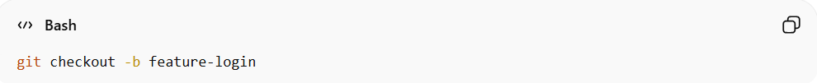
git checkout -b feature-login
- Always create a separate branch for your changes.

Step 2: Make Changes and Commit
# Source: AI Source: Provided by: [Data Path: Persons Table -> ID Column: 1, Name_En Column: Motasem Essam] -> From: [Chatgpt (GPT‑5 Mini)] on [2/19/2026]
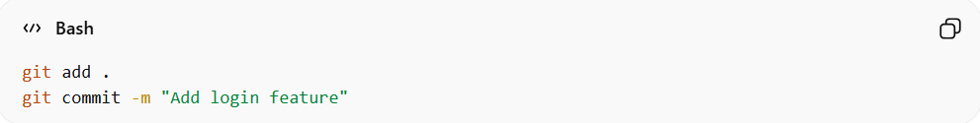
git add .
git commit -m "Add login feature"
- Commit meaningful, organized changes.

Step 3: Push Your Branch to GitLab
# Source: AI Source: Provided by: [Data Path: Persons Table -> ID Column: 1, Name_En Column: Motasem Essam] -> From: [Chatgpt (GPT‑5 Mini)] on [2/19/2026]
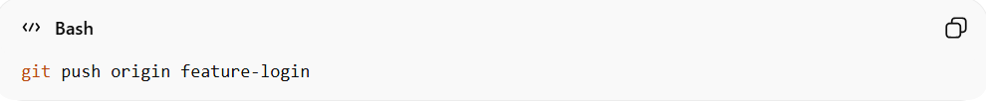
git push origin feature-login
- Uploads your local branch to the GitLab remote repository.

Step 4: Open a Merge Request
# Source: AI Source: Provided by: [Data Path: Persons Table -> ID Column: 1, Name_En Column: Motasem Essam] -> From: [Chatgpt (GPT‑5 Mini)] on [2/19/2026]
On GitLab web UI:
- Go to your repository on GitLab.
- Click Merge Requests → New Merge Request.
- Select:
  - Source branch: Your feature branch (feature-login)
  - Target branch: Usually main or develop
- Fill in title and description describing your changes.
- Assign reviewers (optional but recommended).
- Click Submit Merge Request.

Step 5: Review & Merge
# Source: AI Source: Provided by: [Data Path: Persons Table -> ID Column: 1, Name_En Column: Motasem Essam] -> From: [Chatgpt (GPT‑5 Mini)] on [2/19/2026]
- Reviewers can comment, approve, or request changes.
- If approved, click Merge to integrate the branch into the target branch.
- If there are conflicts:
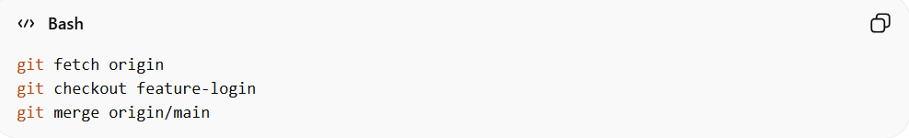
git fetch origin
git checkout feature-login
git merge origin/main
Resolve conflicts, commit, and push again.

Best Practices
# Source: AI Source: Provided by: [Data Path: Persons Table -> ID Column: 1, Name_En Column: Motasem Essam] -> From: [Chatgpt (GPT‑5 Mini)] on [2/19/2026]
- Keep merge requests small and focused for easier review.
- Always update your branch with the latest target branch to avoid conflicts.
- Add descriptive commit messages for clarity.
- Use draft merge requests if your feature isn’t ready for full review.

Create merge request in gitlab

Step 1 open jira
# Source: ScreenShots Source: Provided by: [Persons Table -> ID Column: 1, Name_En Column: Motasem Essam] -> Tool: [Lightshot Program] -> From [Windows] on [2/19/2026]
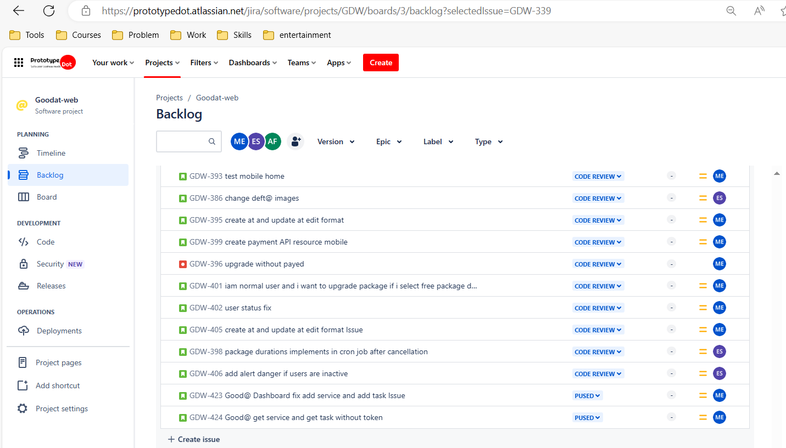

Step 2 open ticket
# Source: ScreenShots Source: Provided by: [Persons Table -> ID Column: 1, Name_En Column: Motasem Essam] -> Tool: [Lightshot Program] -> From [Windows] on [2/19/2026]
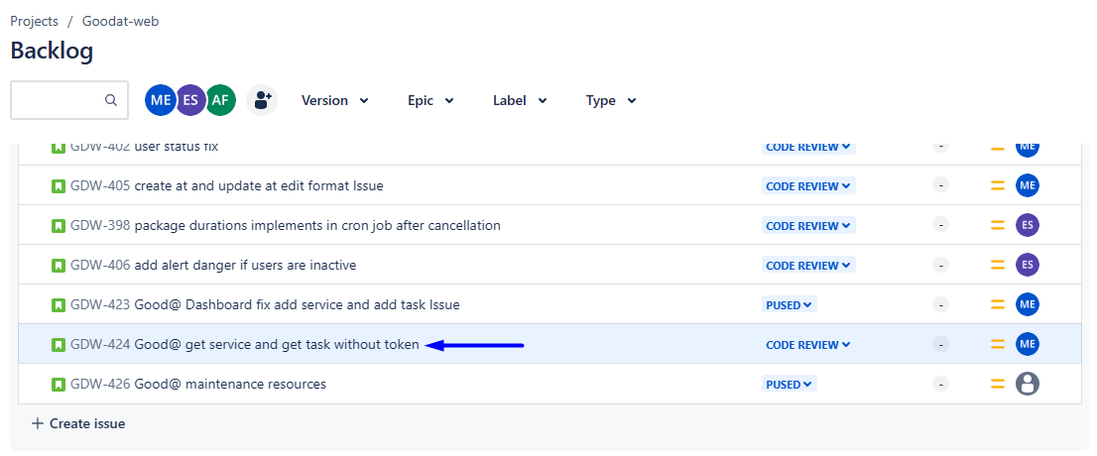

Step 3 open gitlab
# Source: ScreenShots Source: Provided by: [Persons Table -> ID Column: 1, Name_En Column: Motasem Essam] -> Tool: [Lightshot Program] -> From [Windows] on [2/19/2026]
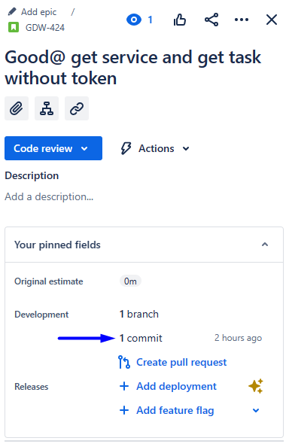
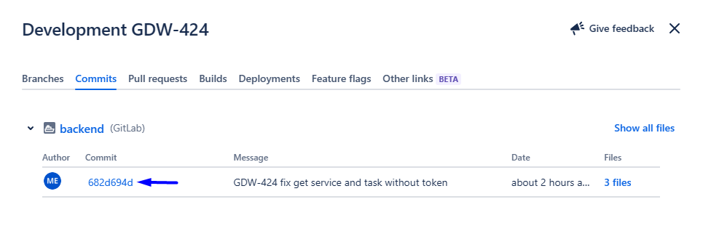

Step 4 open merge request
# Source: ScreenShots Source: Provided by: [Persons Table -> ID Column: 1, Name_En Column: Motasem Essam] -> Tool: [Lightshot Program] -> From [Windows] on [2/19/2026]
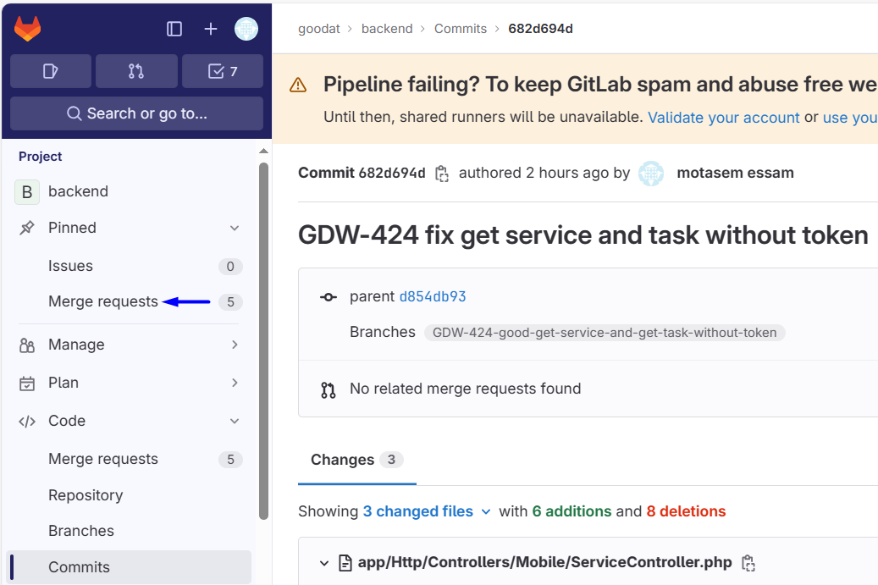

Step 5 create merge request
# Source: ScreenShots Source: Provided by: [Persons Table -> ID Column: 1, Name_En Column: Motasem Essam] -> Tool: [Lightshot Program] -> From [Windows] on [2/19/2026]
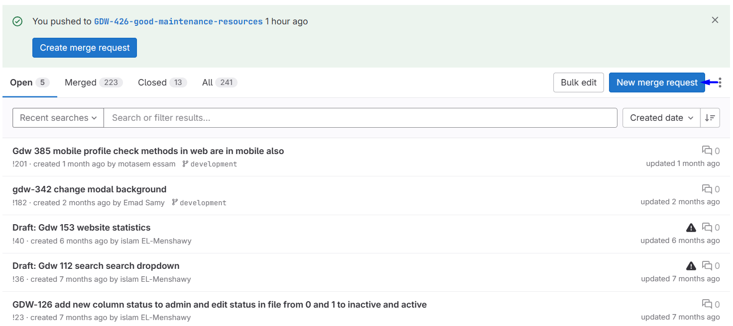
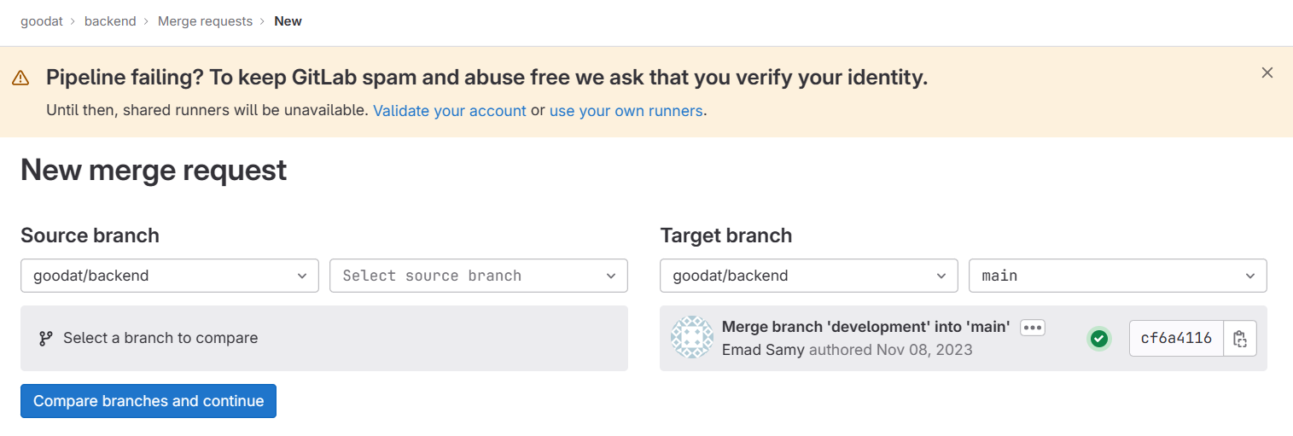
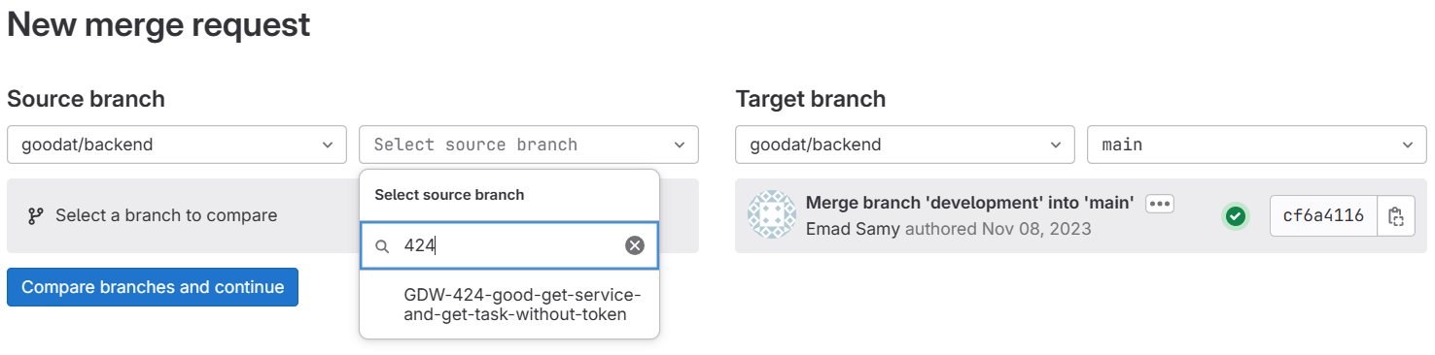
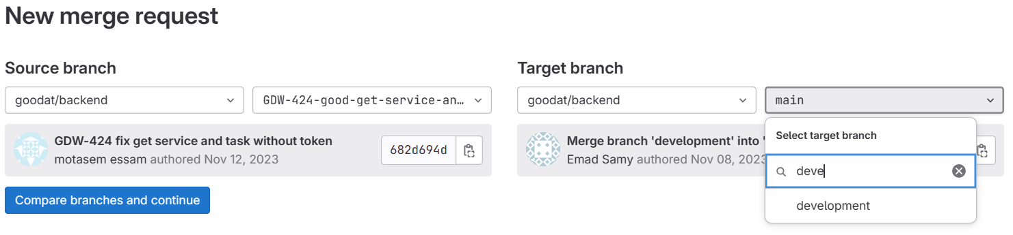
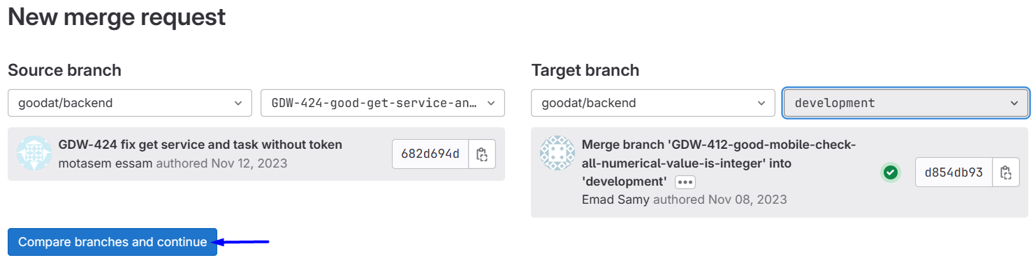
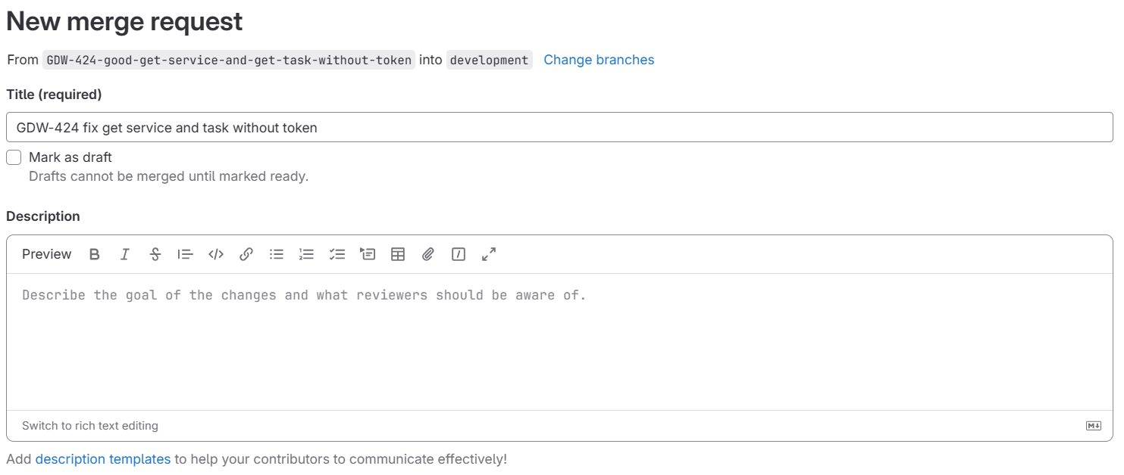
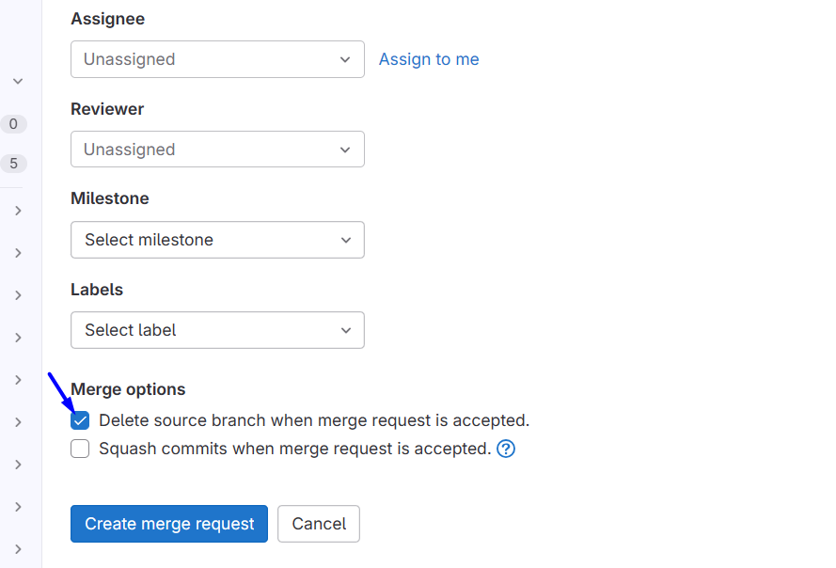
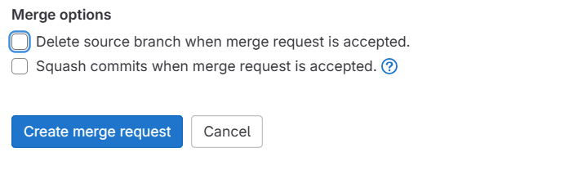
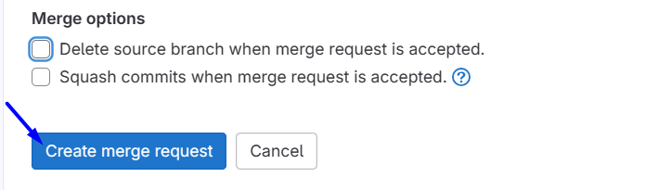
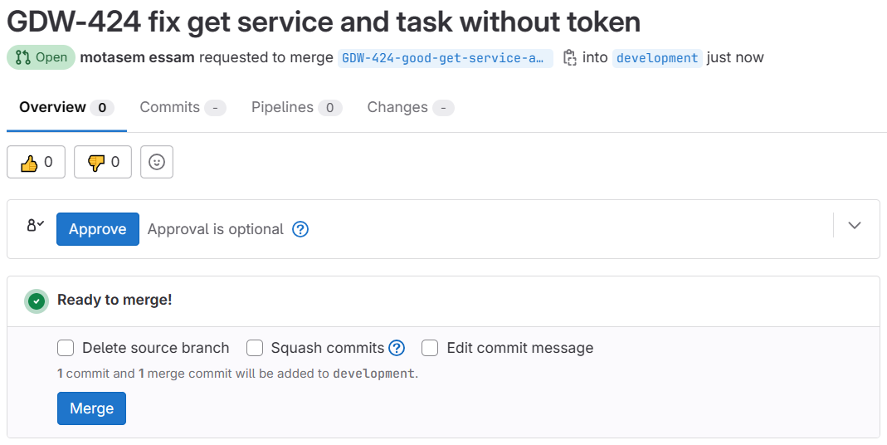

Step 6 check merge request
# Source: ScreenShots Source: Provided by: [Persons Table -> ID Column: 1, Name_En Column: Motasem Essam] -> Tool: [Lightshot Program] -> From [Windows] on [2/19/2026]

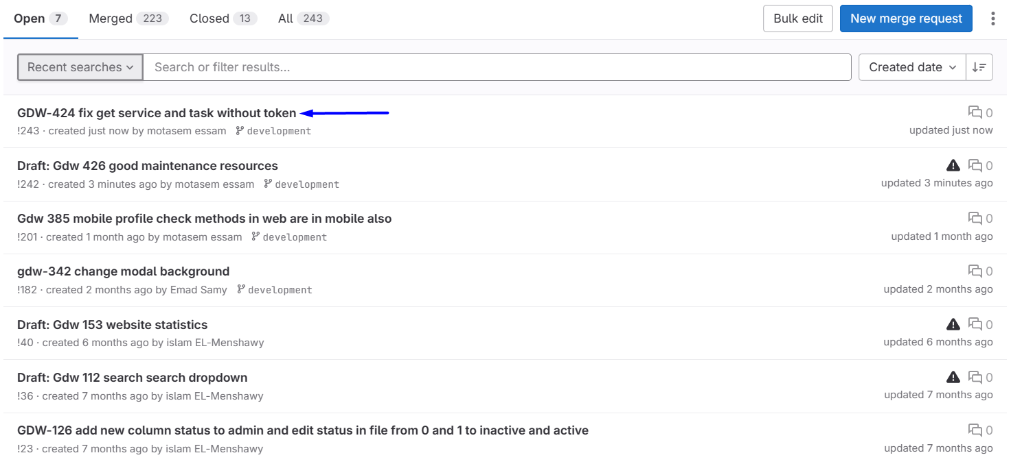
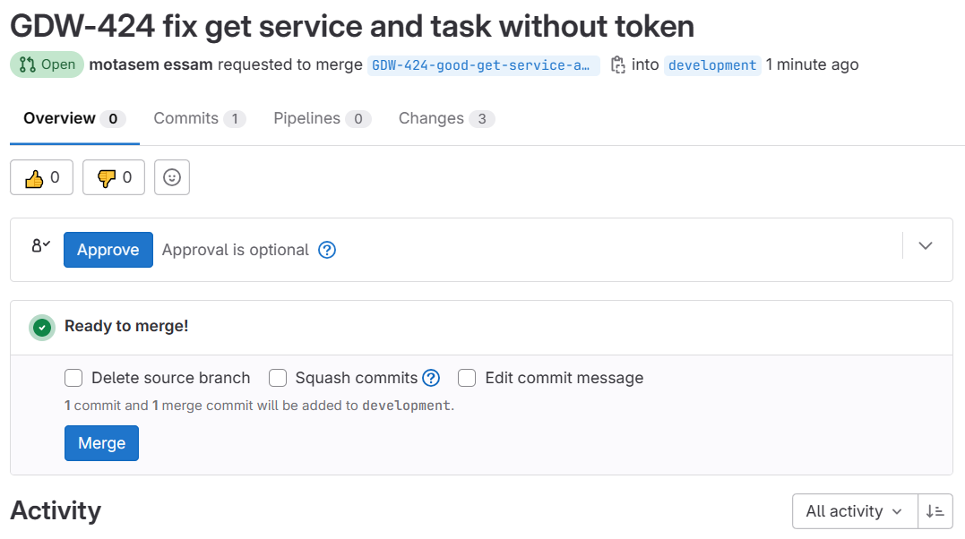
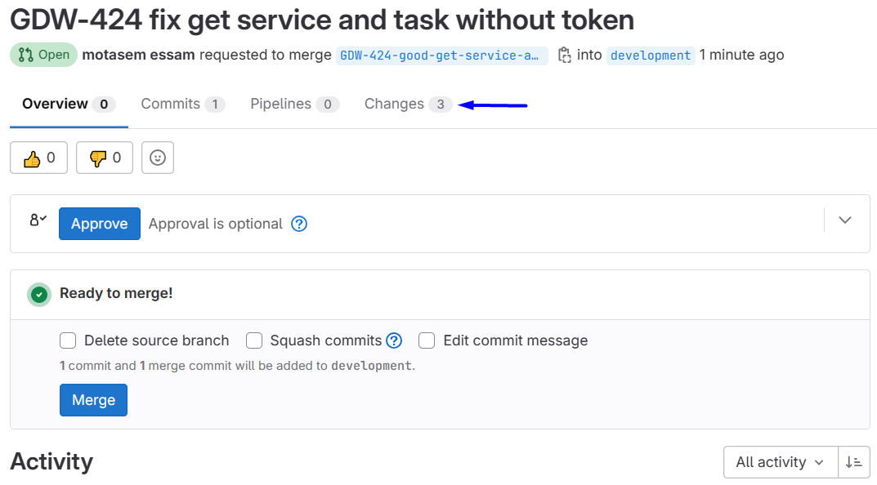
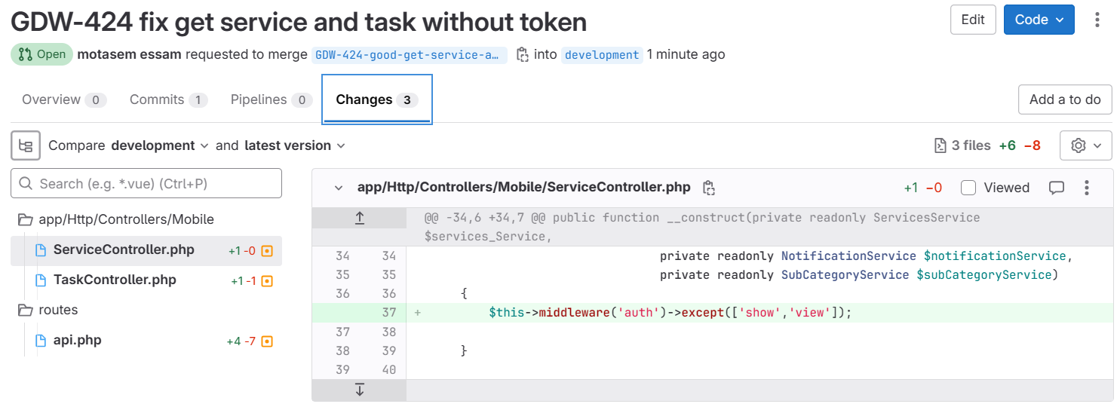

💡 Summary:
# Source: AI Source: Provided by: [Data Path: Persons Table -> ID Column: 1, Name_En Column: Motasem Essam] -> From: [Chatgpt (GPT‑5 Mini)] on [2/19/2026]
A Merge Request is GitLab’s way to safely propose changes from one branch to another, get team feedback, and merge after review. It ensures collaboration and protects the main branch from breaking changes.

